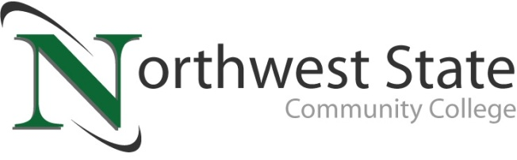

Practical Nursing Program
Application Packet

Application Deadlines
Fall 2022: February 1, 2022 at 5:00 pm
Spring 2023: September 1, 2022 at 5:00 pm

Admission Process
The Practical Nursing Program is a selective-admission health program, providing students with the opportunity sit for the National Council Licensure Exam-Practical Nurse following graduation.

Part 1: College Admission Process
Step 1 Apply to Northwest State Community College.
Step 2 Submit any relevant transcripts directly to
Northwest State Community College
Office of the Registrar
22600 State Route 34
Archbold, OH 43502
Step 3 Complete an academic advising appointment with a NSCC advisor in the Advising Center or with your designated faculty advisor.

Part 2: Program Qualification Requirements
Step 1 Submit the nursing application only (1 page) by the designated deadline to:
Return Application to:
Division of Nursing & Allied Health
22600 State Route 34
Archbold, Ohio 43502
mbuehrer@northweststate.edu
PHONE: 419.267.1246
FAX: 419.267.5524
- Applicants must have a college level cumulative GPA of 2.25 or higher. The NSCC cumulative GPA will be considered first to verify the applicant’s GPA; if the Northwest State cumulative GPA is below 2.25, then transfer courses found in the Practical Nursing curriculum plan will be used to refigure a cumulative GPA.
- Applicants must meet college level reading, writing, and mathematics or successfully complete any developmental coursework, as needed.
- Complete all pre-requisite general education coursework prior to application submission.
Step 2 It is the applicant’s responsibility to notify the College and the Division of Nursing & Allied Health of any name (legal), home address, email address and/or phone number changes. Failure to update contact information can prevent applicants from receiving important communication regarding admission to the program, which will result in the applicant’s name being removed from the application list.

Part 3: Program Acceptance and Notification
All applicants who meet the program qualification requirements are placed on the eligible list. Applicants will be notified of their admittance via the NSCC email. If a student declines their seat for admission, the next qualified applicant will be admitted.
Applications of applicants not admitted will remain on file for possible admission for a future semester. Denied applicants should meet with their academic advisor or faculty advisor to discuss strategies for meeting nursing admission criteria or opportunities in other NSCC health programs.
In accordance with federal regulations and state law, NSCC policy prohibits discrimination against any individual for any reasons of race, color, religion, national origin, sex, sexual orientation, qualified disability, age (40 or older), or veteran status. Equal opportunity will be extended to all individuals.

Practical Nursing Program
Admission Application
Today’s Date Semester Plan to Start
- Personal Information (Please print or type)
Last Name |  | First Name |  | Middle Initial
Other Legal  Name Used |  | First Name |  | Date of Birth
Street Address |  | City, State |  | Zip Code
Home Phone |  | Cell Phone
NSCC Email |  | NSCC Student  ID No. (N#)
- Academic History
College Attended – Most Recent First | Dates | Degree Conferred / Date / Major

K-12 Education |  | Year Completed
High School Name | High School Address
GED

Nursing and/or Allied Health Certificate, Certification, and/or Licensure
Field of Study | Certification Number/ License Number | State of Registration  (or Agency)

- Additional Requirements after Admission but Before Beginning Program
- State-tested Nursing Assistant Certification (must complete the state test)
- American Heart Association BLS Provider CPR Certification
- BCI and FBI criminal background checks are required 6 to 8 weeks before entering the nursing program. A conviction for a misdemeanor or felony may affect a student’s eligibility to enter the nursing program or participation in clinical experiences. Admitted students will be instructed when to complete fingerprinting.
- Drug Screen 10-panel is required 6 – 8 weeks before entering nursing program.
- Physical Health Exam and Immunizations/Vaccines required by clinical agencies must be submitted by due date.

