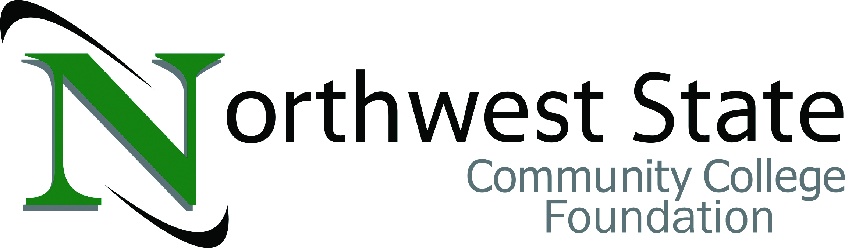­­

**NOMINATION FORM**

2023-2024

**Award Description:** *Making a Difference Awards* are presented by the NSCC Foundation Board to recognize and celebrate the people and organizations committed to bettering their community and to increase awareness of their contributions across the communities served by Northwest State Community College.

**Eligibility:** Three awards will be presented annually to candidates who have had a positive impact on the five-county area. Posthumous nominations are also considered. One award will be presented to an individual, one to a business and the third will be presented to an organization.

*Examples of possible nominees include;*

* ***(individual)****philanthropist, inventor, employer, educator, volunteer/advisory board member,*
* ***(business)****any business creating opportunities through services, products or employment opportunities,*
* ***(organizations)****Jaycees, Boy/Girl Scouts of America, The Open Door ‘transitional living and learning’ program, etc.*

**Nomination Criteria:**

1. Evidence that the nominee for the NSCC *Making a Difference Award* has displayed ongoing dedication and commitment towards contributing to the quality of life in northwest Ohio and/or proven excellence in his/her field of endeavor(s) while having a positive impact on the Northwest State five-county area.

***Please note: it is not necessary that the candidate reside in/work in the five-county area. For example, it may be a corporation headquartered in California who opens/purchases/partners with a local company creating job opportunities in the five-county area.***

1. Evidence that the nominee upholds ethical standards and honorable character attributed to quality leadership and mentorship in our community or relationship to the college.

Note: Please be aware that the candidates ***will not*** be contacted for information of any kind. The accompanying page has outlined the four key areas for evaluating candidates. Realizing that all of these categories may not apply to every nominee, it is critical that complete and accurate information is provided for the categories that are applicable. The committee is relying on the nominator to provide as much background information on the candidate as they can for proper evaluation.

Nominator:

Home Phone: Work Phone:

E-mail:

Please return nomination form by December 16, 2023:

Foundation Nomination Committee c/o Robbin Wilcox

Northwest State Community College

22600 St. Rte. 34

Archbold, OH 43502

rwilcox@northweststate.edu



**NOMINATION FORM**

Individual Business Organization

Nominee: Category: ⬜ ⬜ ⬜

Contact Name: (if business or organization)

Home Phone: Work Phone:

E-mail:

Address:

**Personal Reference**

How do you know this nominee?

**Service Area**

How has the candidate’s contributions/involvement with community made a difference for NSCC, its students and Northwest Ohio?

**Professional Success**

Give examples of how the nominee has demonstrated excellence in community and county through contributions to major civic, business, and professional activities.

Organization/Activity Involvement (Describe)

List special awards/honors or recognition received.

**Volunteer Work**

Give examples of community and county volunteer work.

Organization/Activity Involvement (Describe)

List special awards/honors or recognition received.

Additional supportive documentation is welcome.