Did you know…Students enrolled in classes or a certificate program at
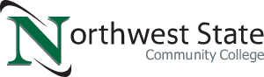
who are eligible for
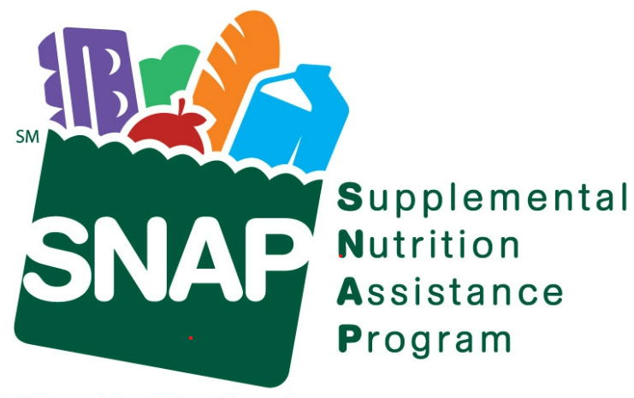
may be able to receive assistance with textbooks, PFCC copays, gas cards, car repairs, required uniforms and equipment for their field of study as well as a loaner laptop program?

Northwest State Community College, through a partnership with the Ohio Department of Job & Family Services, is able to help break down barriers to education by assisting with needs outside of the classroom. The goal is to get local Ohioans working at in-demand careers with as few obstacles as possible.

Contact the NSCC Grants Office today at 419-267-1400
or email at
scheeseman@northweststate.edu
to verify eligibility or begin the enrollment process.

