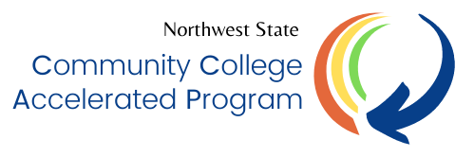 | Northwest State Community College CCAP Application

Full Name: |  |  |  | Date:
 | Last | First | M.I.

Address:
 | Street Address | Apartment/Unit #

 | City | State | ZIP Code | County

Phone: |  | NSCC Email:

Date of Birth: |  | NSCC ID#: | N00 | Last 4 of SS#:

What assistance do you need?

Job Related Assistance | YES | NO | Auto Repair | YES | NO

Assistance with Books/Fees | YES | NO | Transportation | YES | NO
Tuition (Gap Scholarships) | YES | NO | Dependent Care | YES | NO
Other Needs: | _________________________________________________________________________________

Have you received assistance from any other agency or community resource? If so:

Agency Name____________________________________Date_____________Assisted with____________________

CCAP benefits are available to students that are eligible and receive SNAP benefits (food assistance) through Job and Family Services (JFS).

Are you currently receiving SNAP Benefits through JFS? | YES | NO

If No, please complete the following steps:

- Scan the QR code below to complete the screening tool for an initial determination of your SNAP eligibility
- Complete the application for Cash, Food, or Medical Assistance by applying online at benefits.ohio.gov or complete a paper application, available in the TRIO-SSS Office.

Northwest State CCAP program will verify your eligibility with JFS before issuing CCAP benefits. If your SNAP eligibility changes, it could affect your CCAP eligibility.

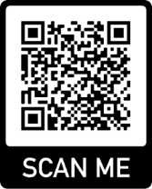

How did you learn about NSCC CCAP?
NSCC Faculty/Staff: | YES |  | NO | NSCC Website | YES |  | NO
Email | YES |  | NO | Another CCAP Student | YES |  | NO
TRIO Success Coach | YES |  | NO | Social Media | YES |  | NO
Mailing/Flyer | YES |  | NO | Other: | ___________________

I certify that my answers are true and complete to the best of my knowledge.
Signature: ___________________________________________ | Date: | ___________________

Completed applications may be mailed, hand-delivered, or emailed.

Return to:  Financial Aid  22600 St Rt 34  Archbold, OH 43502 | Email: finaid@northweststate.edu  (Please indicate “CCAP Application – Your Name” in the subject line  Phone: 419-267-5511

