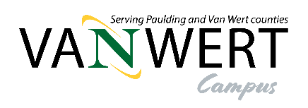
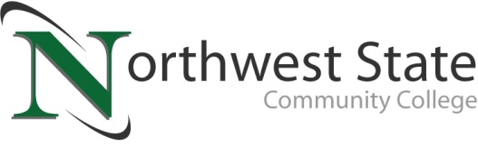

DATE: March 17, 2025
CONTACT: Jim Bellamy 419.267.1267 jbellamy@NorthwestState.edu

NORTHWEST STATE VAN WERT CAMPUS ANNOUNCES FALL 2025 COURSES

ARCHBOLD, OHIO – Your Van Wert Campus of Northwest State Community College is excited to announce the opening of registration for our Fall 2025 semester. And, most exciting of all, the Van Wert Campus will be open and fully operational for our August 20, 2025 semester start!
Our onsite class offerings allow enrollment in several career pathways:

Associate Degrees:
Accounting
Banking & Finance
Business Management
Entrepreneurship
Marketing
Computer Programming
Cyber Security Network Administration
Electrical Engineering
Industrial Technologies

Short-Term Certificates:
Accounting Assistant
Entrepreneurship
Marketing
Computer Technician
Cyber Security
Industrial Electrical
Medical Coding and Billing (online only)

Classes are available for all student groups, including traditional aged college students, non-traditional/part-time students, students looking to transfer credit back to their home university, workforce development and upskilling, and college credit plus/dual enrollment.

Additionally, your Van Wert Campus is offering our First Course Free scholarship to go along with the $900,000 in NSCC Foundation scholarships awarded annually and institutional scholarships that can provide up to 100% tuition.

To begin your future educational career or gather more information, please visit the Van Wert Campus website at NorthwestState.edu/VanWert. On our Van Wert Campus website, you have access to review all our Academic Divisions, ask any Admissions questions, review Financial Aid and scholarship information, and apply to begin your future at Northwest State Community College. The current courses offered can be found at NorthwestState.edu/calendars.

More information on courses and our Van Wert Campus can be directed to Dr. Jon Tomlinson by emailing vanwert@northweststate.edu, calling our Van Wert Campus at 419-267-1399, or visiting our current storefront at 122 N. Washington Street. If you have Enrollment questions, please email Rachel Verville at rverville@northweststate.edu.

#####

Northwest State Community College is an accredited two-year, state-assisted institution of higher education that has served northwest Ohio since 1969. Northwest State is committed to providing a quality, affordable education with personal attention and small class sizes. The College offers associate degrees with numerous transfer options, short-term certificate programs, and workforce training programs designed to meet the needs of local businesses and industries. For more information, visit NorthwestState.edu or call 419.267.5511.

