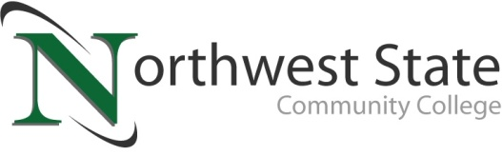

Date: December 19, 2022
Contact: Jim Bellamy, 419.267.1267 jbellamy@NorthwestState.edu

NSCC RECOGNIZES NURSING GRADUATES AT PINNING CEREMONY

ARCHBOLD, OHIO –Northwest State Community College recognized its Nursing graduates at a recent pinning ceremony in the following areas: Practical Nursing (PN) and Registered Nursing (RN). The pinning ceremony took place on Friday, December 16th on the Archbold campus.

Graduates of the nursing programs are eligible to take the National Council Licensure Exam (NCLEX) and enter directly into the workforce, or they may transfer their credits for additional study. During the ceremony, the College recognized fourteen students for induction into the Alpha Delta Chapter of the Alpha Delta Nu Nursing Honor Society. In order to qualify, students must maintain a minimum 3.0 grade point average, with at least a B in all nursing classes.

Northwest State congratulates the following students for completing these healthcare programs:

Practical Nursing:
Defiance County: Kelsey Ayres (Hicksville), Jasmyn Justice (Defiance)
Fulton County: Damara Netcher (Wauseon), Arlinda Rohda (Wauseon)
Williams County: Mercedees Carr (Edgerton), Mary Safemaster (Bryan)

Registered Nursing:
Defiance County: Madison Brown* (Defiance), Emily Woodbury* (Defiance)
Fulton County: Desiree Saldivar (Wauseon), Morgan Sanford (Wauseon), Morgyn Siegel (Archbold)
Henry County: Ed Bump (McClure), Amanda Hutton (Napoleon), Natalie Meyer* (Hamler), Katelyn Schroeder (Napoleon)
Paulding County: Trevor Speiser (Oakwood)
Williams County: Breanna Doriot (Stryker), Jessica Hatlevig (Edgerton), Sandra Mummert (Bryan), Vanessa Stotz (Edgerton)

Names with a * denote Alpha Delta Nu honors recipient

###

Northwest State Community College is an accredited two-year, state-assisted institution of higher education that has served northwest Ohio since 1969. Northwest State is committed to providing a quality, affordable education with personal attention and small class sizes. The College offers associate degrees with numerous transfer options, short-term certificate programs, and workforce training programs designed to meet the needs of local businesses and industries. For more information, visit NorthwestState.edu or call 419.267.5511.

FOR MEDIA ONLY: For quick reference, all media photos are available at
https://northweststate.smugmug.com/20221216-NSCC-nursing-pinning-ceremony-MEDIA/

Please note: Morgan Sanford and Trevor Speiser were not available for photography.

