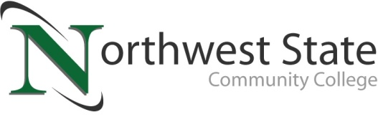

DATE: December 14, 2022
CONTACT: Jim Bellamy 419.267.1267 jbellamy@NorthwestState.edu

REGISTRATION IS OPEN FOR ONSITE CLASSES IN VAN WERT FOR JANUARY 2023

VAN WERT, Ohio – Northwest State Community College would like to invite current and potential students to register for onsite courses in Van Wert scheduled to start on January 17, 2023. In addition to the original course schedule released in November, we have been able to add an introductory Statistics course on Wednesday evening. The courses (below) will be offered as one-night-a-week lecture courses, with the remaining classwork being completed online. Van Wert Health, located at 1250 S. Washington Street, has graciously agreed to allow Northwest State to house classes in the hospital’s conference rooms while our Sycamore Street location undergoes renovation.

Our Van Wert Campus schedule for Spring 2023 will allow students to enter several of Northwest State’s career pathways, including Business, Healthcare, Social Behavioral Sciences, Communications, English, & Humanities, Public Services, Engineering Technology, Industrial Technology, and Math & Natural Sciences. The second 8-week section of onsite Van Wert courses will begin in March in which we plan to offer CIS14 Microsoft Applications and IND107 Print Reading & Sketching, among others.

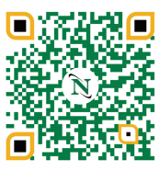
To begin your future educational career or gather more information, please visit the Van Wert Campus website at https://northweststate.edu/vanwert. On our Van Wert Campus website, you have access to review all our Academic Divisions, ask any Admissions questions, review Financial Aid and scholarship information, and apply to begin your future at Northwest State Community College. This QR code will take you right there!

You may contact the Dean, Dr. Jon Tomlinson, directly by emailing jtomlinson@northweststate.edu, or visiting our storefront at 122 N. Washington Street. We look forward to serving YOU!

Day | Course Offering
Monday (5:45-8:15pm) | ENG111 Composition 1 (3 credits)
Tuesday (5:45-8:15pm) | BUS101 Introduction to Business (3 credits)
Wednesday (7:30-9:00pm) | STA120 Introduction to Statistics (3 credits)
Thursday (5:45-8:15pm) | IND120 Industrial Electricity (3 credits)
Saturday  9:00-10:50am on January 21, February 4, February 18, and March 4  11:00am-12:50pm on January 21, February 4, February 18, and March 4 | GSD100 Success Seminar (1 credit)  Writing Center (optional, 0 credit)

###

Northwest State Community College is an accredited two-year, state-assisted institution of higher education that has served northwest Ohio since 1969. Northwest State is committed to providing a quality, affordable education with personal attention and small class sizes. The College offers associate degrees with numerous transfer options, short-term certificate programs, and workforce training programs designed to meet the needs of local businesses and industries. For more information, visit NorthwestState.edu or call 419.267.5511.

