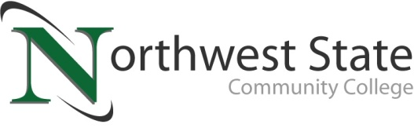

DATE: December 12, 2022
CONTACT: Jim Bellamy 419.267.1267 jbellamy@NorthwestState.edu

NORTHWEST STATE COMMUNITY COLLEGE BOARD OF TRUSTEES
PROVIDE VALUED INPUT INTO COLLEGE’S NEW STRATEGIC PLAN

Archbold, Ohio – The Northwest State Community College Board of Trustees met in regular session on Friday, December 9 at the Archbold Campus. As part of the meeting, the Board of Trustees members participated in a compression planning “dotting session”, providing valued input into the College’s new Strategic Plan, which will be in effect 2023-2026. The College has previously held external stakeholder listening and dotting sessions in all six service counties, as well as learner and employee sessions internally.

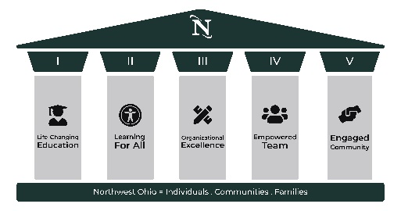
STRATEGIC PLAN
The current Strategic Plan (2020-2023) includes five goals or pillars:
- Life-Changing Education (Create and maintain high quality, transformative, and safe educational environments that meet the needs of our current and future learners.)
- Learning For All (Promote collaborative partnerships that serve our learners and provide an equitable opportunity to succeed.)
- Organizational Excellence (Improve NSCC’s institutional effectiveness to create a sustainable, stakeholder-focused and high-performing organization.)
- Empowered Team (Cultivate and sustain a positive culture that empowers team members to fulfill our mission.)
- Engaged Community (Create intentional communications and interactions between the College and its stakeholders to strengthen our community relationships.)

You can view the full Strategic Plan at NorthwestState.edu/strategic-plan.

In other Board action:
- Approved the promotion of Brittany Thompson to Director of Admissions.
- Approved the employment of Adriana Lopez to Financial Aid Counselor, Gina Kasch to Fundraising Coordinator, and Susan Cheesman to Grants Officer.
- Approved the transfer of Kristi Von Deylen to Administrative Assistant-Nursing & Allied Health, and Kara Flesher to Academic Advisor.
- Approved the 2022 Affordability and Efficiency Report.
- Approved the 2021-2022 College Audit.
- Approved a new Board Self-Evaluation policy.
- Accepted a gift (kinescope hand-held microscope) to the College.
- Approved miscellaneous employment contracts, and three resignations, and the renewal of Probationary Faculty and Non-Teaching Faculty contracts.

###

Northwest State Community College is an accredited two-year, state-assisted institution of higher education that has served northwest Ohio since 1969. Northwest State is committed to providing a quality, affordable education with personal attention and small class sizes. The College offers associate degrees with numerous transfer options, short-term certificate programs, and workforce training programs designed to meet the needs of local businesses and industries. For more information, visit NorthwestState.edu or call 419.267.5511.

