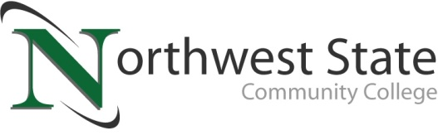

DATE: November 7, 2022
CONTACT: Jim Bellamy 419.267.1267 jbellamy@NorthwestState.edu

NORTHWEST STATE COMMUNITY COLLEGE ANNOUNCES
SPRING 2023 CLASSES IN VAN WERT

VAN WERT, Ohio – Your Van Wert Campus of Northwest State Community College is excited to announce the release of its spring 2023 semester class schedule. Starting Tuesday, January 17th, Northwest State will begin offering one-night-a-week, face-to-face classes in Van Wert.

Van Wert Health, located at 1250 S. Washington Street, has graciously agreed to allow Northwest State to house classes in the hospital’s conference rooms while our Sycamore Street location undergoes renovation. The January class offerings will be hybrid in nature, meaning lecture one-night-a-week from 5:45 – 8:15pm with the remaining classwork being completed online. Classes will be 8 weeks in length and are scheduled to be held on Monday, Tuesday, or Thursday evenings, with our student Success Seminar and optional Writing Center assistance taking place on alternating Saturday mornings.

The schedule below will allow students to enter several of Northwest State’s career pathways, including Business, Healthcare, Social Behavioral Sciences, Communications, English, & Humanities, Public Services, Engineering Technology, Industrial Technology, and Math & Natural Sciences.

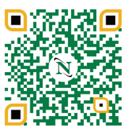
To begin your future educational career or gather more information, please visit the Van Wert Campus website at https://northweststate.edu/vanwert. On our Van Wert Campus website, you have access to review all our Academic Divisions, ask any Admissions questions, review Financial Aid and scholarship information, and apply to begin your future at Northwest State Community College. This QR code will take you right there!

You may contact the Dean, Dr. Jon Tomlinson, directly by emailing jtomlinson@northweststate.edu, or visiting our storefront at 122 N. Washington Street. We look forward to serving YOU!

Day | Course Offering
Monday (5:45-8:15pm) | ENG111 Composition 1 (3 credits)
Tuesday (5:45-8:15pm) | BUS101 Introduction to Business (3 credits)
Thursday (5:45-8:15pm) | IND120 Industrial Electricity (3 credits)
Saturday  9:00-10:50am on January 21, February 4, February 18, and March 4  11:00am-12:50pm on January 21, February 4, February 18, and March 4 | GSD100 Success Seminar (1 credit)  Writing Center (optional, 0 credit)

###

Northwest State Community College is an accredited two-year, state-assisted institution of higher education that has served northwest Ohio since 1969. Northwest State is committed to providing a quality, affordable education with personal attention and small class sizes. The College offers associate degrees with numerous transfer options, short-term certificate programs, and workforce training programs designed to meet the needs of local businesses and industries. For more information, visit NorthwestState.edu or call 419.267.5511.

