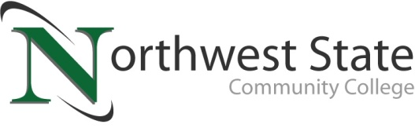

DATE: November 1, 2022
CONTACT: Jim Bellamy 419.267.1267 jbellamy@NorthwestState.edu

NORTHWEST STATE COMMUNITY COLLEGE CENTER FOR LIFELONG LEARNING
TO PRESENT “WHAT IS THE ABILITY CENTER AND ASSISTANCE DOGS OF AMERICA?” PROGRAM

Archbold, Ohio – The NSCC Center for Lifelong Learning will host speakers from the Ability Center in Toledo, Ohio with Assistance Dogs of America and Kristi Rotroff, Director of Library Services at Northwest State Community College who has experience in raising puppies for Leader Dogs for the Blind. The Ability Center advocates for people with disabilities and are catalysts for all they can achieve. One in four people have a disability that impacts the way they connect with the world around them. The Ability Center works as an advocate and thought leader, changing both attitudes and real world conditions for people with disabilities. They advocate, educate, partner, and provide services supporting people with disabilities to thrive within their community.

Kristi (zumFelde) Rotroff grew up in rural Wauseon and participated in Fulton County 4-H for thirteen years. In the mid-1980s, the family raised two puppies for a program that was a partnership between Ohio 4-H and Ohio Leader Dogs for the Blind. This project was very rewarding, and one of the puppies ended up living and working with a vision-impaired man for over ten years. More recently, Kristi was a puppy raiser for the Leader Dogs for the Blind organization in Rochester, Michigan.

Adults 50 and over are invited to attend a special program, presented by the NSCC Center for Lifelong Learning (CFLL) at the Archbold Campus on Friday, November 18 in the Voinovich Auditorium, from 9:00 a.m. to 1:00 p.m. There is a $14 charge per person to attend. A small continental breakfast will be served at 9:00 a.m., followed by speakers at 9:30 a.m. A lunch will also be served from noon until 1:00 p.m.

TO SAVE YOUR SPOT, AND FOR MORE INFORMATION…
Reservations are now being accepted for this special CFLL program, by calling Deb Wikstrom at 419.944.6195, or by email at dwikstrom@NorthwestState.edu. For more information on the CFLL, and other upcoming programs, please visit NorthwestState.edu/lifelong-learning.

###

Northwest State Community College is an accredited two-year, state-assisted institution of higher education that has served northwest Ohio since 1969. Northwest State is committed to providing a quality, affordable education with personal attention and small class sizes. The College offers associate degrees with numerous transfer options, short-term certificate programs, and workforce training programs designed to meet the needs of local businesses and industries. For more information, visit NorthwestState.edu or call 419.267.5511.

