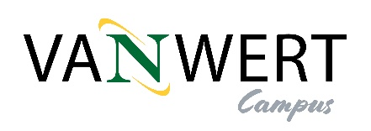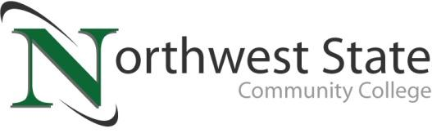 

**DATE:** October 17, 2024

**CONTACT:** Jim Bellamy 419.267.1267 jbellamy@NorthwestState.edu

**NORTHWEST STATE VAN WERT CAMPUS ANNOUNCES SPRING 2025 COURSES**

*VAN WERT, OHIO* – Your Van Wert Campus of Northwest State Community College is excited to announce the opening of registration for our Spring 2025 semester. Until the Van Wert Campus is fully operational, we have once again partnered with Van Wert Health to host courses starting in January 2025. Classes are scheduled to be held in an 8-week hybrid format (1.5 hours of face-to-face lecture with online assignments) during the week.

Our onsite class offerings allow you to enter several career pathways – Business, Computer Systems, Industrial Tech, and Bachelor’s Bound (i.e. those looking to ultimately transfer to a 4-year university). Classes are available for all student groups, including traditional aged college students, non-traditional/part-time students, students looking to transfer credit back to their home university, workforce development and upskilling, and college credit plus/dual enrollment.

To begin your future educational career or gather more information, please visit the Van Wert Campus website at **https://northweststate.edu/vanwert**. On our Van Wert Campus website, you have access to review all our Academic Divisions, ask any Admissions questions, review Financial Aid and scholarship information, and apply to begin your future at Northwest State Community College.

More information on courses and our Van Wert Campus can be found at <https://northweststate.edu/vanwert>. Course questions can be directed to Dr. Jon Tomlinson by emailing [jtomlinson@northweststate.edu](mailto:jtomlinson@northweststate.edu), or visiting our storefront at 122 N. Washington Street. If you have Enrollment questions, please email Rachel Verville at [rverville@northweststate.edu](mailto:rverville@northweststate.edu).

|  |  |
| --- | --- |
| **Schedule: 1/13/2025 - 3/8/2025** | **Course Offering** |
| Mondays (5:45-8:15pm) | ACC112 Managerial Accounting (3 credits) |
| Mondays (5:45-8:15pm) | SSC101 Sociology (3 credits) |
| Tuesdays (5:45-8:15pm) | STA120 Introduction to Statistics (3 credits) |
| Tuesdays (5:45-8:15pm) | ECO211 Macroeconomics (3 credits) |
| Wednesdays (5:45-8:15pm) | HUM221 Music Appreciation (3 credits) |
| Wednesdays (5:45-8:15pm) | CIS114 Microsoft Applications (3 credits) |
| Thursdays (5:45-8:15pm) | ENG111 Composition I (3 credits) |
| Thursdays (5:45-7:45pm) | MET100 Intro to Engineering (2 credits) |

|  |  |
| --- | --- |
| **Schedule: 3/17/2025 - 5/10/2025** | **Course Offering** |
| Mondays (5:45-8:15pm) | BUS101 Intro to Business (3 credits) |
| Mondays (5:45-8:15pm) | ACC212 Intermediate Accounting II (3 credits) |
| Tuesdays (5:15-8:15pm) | BIO150 The Human Body (3 credits) |
| Wednesdays (5:45-8:15pm) | ECO211 Microeconomics (3 credits) |
| Wednesdays (5:45-8:15pm) | CIS113 Microsoft Excel (3 credits) |
| Thursdays (5:45-8:15pm) | ENG112 Composition II (3 credits) |
| Thursdays (5:45-7:45pm) | BUS221 Business Law (3 credits) |

###

*Northwest State Community College is an accredited two-year, state-assisted institution of higher education that has served northwest Ohio since 1969. Northwest State is committed to providing a quality, affordable education with personal attention and small class sizes. The College offers associate degrees with numerous transfer options, short-term certificate programs, and workforce training programs designed to meet the needs of local businesses and industries. For more information, visit NorthwestState.edu or call 419.267.5511.*