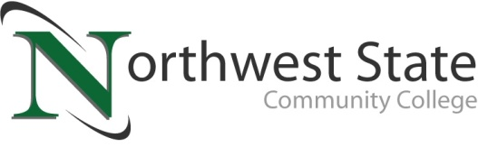

DATE: October 09, 2023
CONTACT: Jim Bellamy 419.267.1267 jbellamy@NorthwestState.edu

NORTHWEST STATE COMMUNITY COLLEGE DELIVERS
“STATE OF THE COLLEGE” ADDRESS

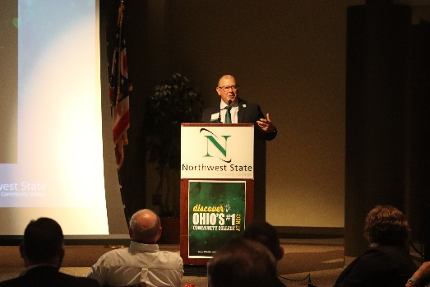
Archbold, Ohio – Northwest State Community College hosted a “State of the College” Address at the Voinovich Auditorium, held on September 28, 2023. In attendance were state officials, business and community leaders, and area educators. Following introductions from NSCC Board of Trustees Chair Scott Mull and Emcee Joel Miller, NSCC President Dr. Todd Hernandez provided an important update on the College’s number one community college ranking (WalletHub, 2023), and the ongoing plans to elevate Northwest Ohio through strategic partnerships, increased access to education, and more. At the conclusion of Dr. Hernandez’s speech, Rep. Jim Hoops provided some state budget updates for higher education, and applauded NSCC’s efforts and success. The event’s closing speaker was Colin Doolittle, a 2006 NSCC graduate and a 2017 NSCC Distinguished Alumni.

KEY TAKEAWAYS
Dr. Hernandez provided a 30-minute speech that included a number of topics that showed the strengths of Northwest State. Key takeaways from the speech included:
- NSCC is proud of its #1 Ohio’s community college ranking (WalletHub report), and is committed to not only upholding that ranking, but continuing to improve the metrics used in the report (cost & financing, educational outcomes, and career outcomes).
Figure 1NSCC President Dr. Todd Hernandez provides his State of the College Address on September 28, 2023
- After posing the question “What’s next?” Dr. Hernandez noted renovations that are scheduled for the B building at the Archbold campus, plus the new Van Wert full-service campus. The goal is to have the Van Wert campus up and running for the fall 2024 semester.
- Dr. Hernandez also discussed his new “Elevate Northwest Ohio” initiative, mirroring the “65% educational attainment rate in NW Ohio by 2025” goal of Governor DeWine. He encouraged strategic community partnerships with non-profits, for-profit business and industry, faith-based entities and elected officials, in an order to make education and training available to as many learners as possible.

STATE PERSPECTIVE
Rep. Jim Hoops took the stage following Dr. Hernandez, and noted that the state recognizes NSCC for its #1 ranking, and more importantly for the work done to make a college education accessible and affordable for all. Of northwest Ohio, Hoops remarked “This part of the state is primed for some good things.” Hoops also credited the state-led TechCred program that NSCC actively promotes to area businesses for workforce development. More information on TechCred is available at https://techcred.ohio.gov/about.

AVAILABLE SOON FOR ON-DEMAND VIEWING
The entire “State of the College” presentation will be available for free on-demand viewing, by visiting the College’s official YouTube page (YouTube.com/NorthwestStateCC). For more information on NSCC education, training and services, please visit NorthwestState.edu or call 419.267.5511 today.

###

Northwest State Community College is an accredited two-year, state-assisted institution of higher education that has served northwest Ohio since 1969. Northwest State is committed to providing a quality, affordable education with personal attention and small class sizes. The College offers associate degrees with numerous transfer options, short-term certificate programs, and workforce training programs designed to meet the needs of local businesses and industries. For more information, visit NorthwestState.edu or call 419.267.5511.

A media photo gallery is available at https://northweststate.smugmug.com/20230928-State-of-the-College-MEDIA/

