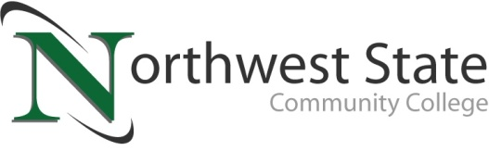

**DATE:** September 30, 2024

**CONTACT:** Jim Bellamy 419.267.1267 jbellamy@NorthwestState.edu

**NORTHWEST STATE, staff bargaining unit**

**reach new three-year agreement**

*Archbold, Ohio* – Negotiations between NSCC Administration and the staff bargaining unit ("staff") had previously reached an impasse, and the process went to fact finding. Both parties accepted the recommendations of the fact finding arbiter and have agreed to a new agreement. The agreement is three years in length, running through June 30, 2027.

**TERMS ANNOUNCED**

Terms of the agreement for all qualifying staff employees are as follows:

* 5% pay increase in year one
* 4% pay increase in years two and three
* The overall pay increase is 13.57% over three years

NSCC President Dr. Todd Hernandez noted "I am thankful to the negotiation teams and the work that was put in to reach a new agreement. I'm excited to move beyond negotiations and refocus efforts on our mission of improving lives and strengthening communities."

###

*Northwest State Community College is an accredited two-year, state-assisted institution of higher education that has served northwest Ohio since 1969. Northwest State is committed to providing a quality, affordable education with personal attention and small class sizes. The College offers associate degrees with numerous transfer options, short-term certificate programs, and workforce training programs designed to meet the needs of local businesses and industries. For more information, visit NorthwestState.edu or call 419.267.5511.*