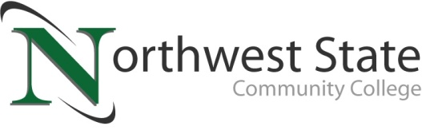

**DATE:** September 12, 2024

**CONTACT:** Jim Bellamy 419.267.1267 jbellamy@NorthwestState.edu

**MEDIA ALERT**

**NSCC TO HOST “STATE OF THE COLLEGE” ADDRESS  
FEATURING AVI ZAFFINI, OACC PRESIDENT***Thursday, September 26, 8:00-9:30 a.m.*

*Archbold, Ohio –*

**Who:** Media representatives from northwest Ohio

**What:** Northwest State Community College will host its 2024 “State of the College” address for community stakeholders, including NSCC Board members, business leaders, elected officials, NSCC distinguished alumni, media members and more. NSCC President Dr. Todd Hernandez will provide the “State of the College” address, and Avi Zaffini, the new President of Ohio Association of Community Colleges (OACC), will provide some important state-level updates at the event.

**When:** Thursday, September 26, 2024, 8:00-9:30 a.m.

Voinovich Auditorium (west side of campus in ‘E’ building)

**misc: Following a complimentary breakfast, NSCC President Dr. Todd Hernandez will provide his “State of the College” 2024 address. Dr. Hernandez will note that NSCC exceeded 400 new learners for the fall semester, along with a presentation on the College’s “Elevate Northwest Ohio” initiative. Avi Zaffini will also provide important state-level updates at the event. Interested attendees are asked to RSVP by September 23, 2024 to Olof Fleming at 419.267.1351 or ofleming@NorthwestState.edu.**

###

*Northwest State Community College is an accredited two-year, state-assisted institution of higher education that has served northwest Ohio since 1969. Northwest State is committed to providing a quality, affordable education with personal attention and small class sizes. The College offers associate degrees with numerous transfer options, short-term certificate programs, and workforce training programs designed to meet the needs of local businesses and industries. For more information, visit NorthwestState.edu or call 419.267.5511.*

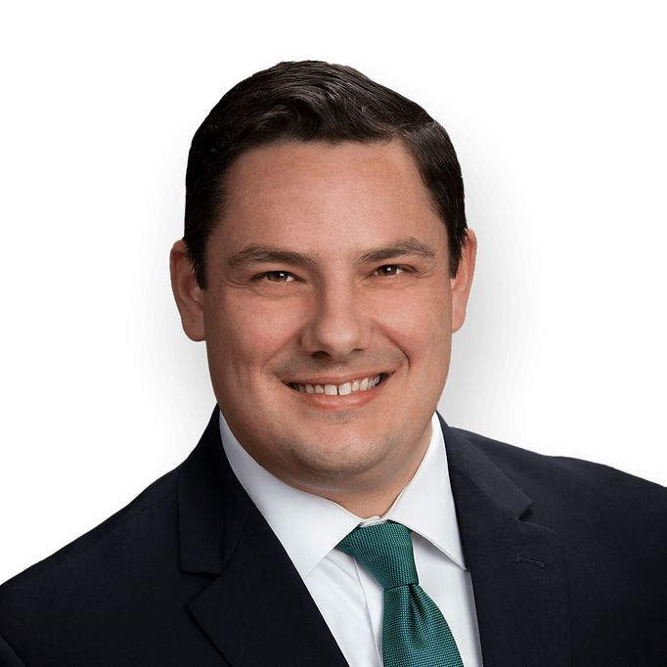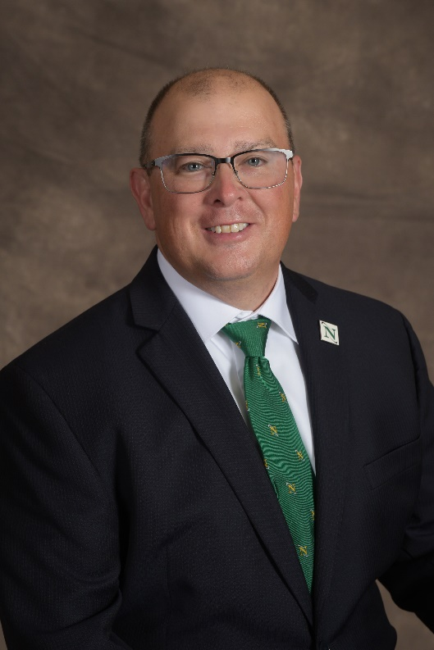

*L to R: Dr. Todd Hernandez, Avi Zaffini*