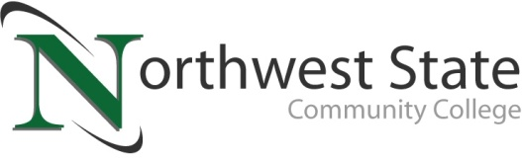

**DATE:** August 26, 2024

**CONTACT:** Jim Bellamy 419.267.1267 jbellamy@NorthwestState.edu

**NORTHWEST STATE COMMUNITY COLLEGE BOARD OF TRUSTEES**

**APPROVES AMENDED INSTITUTIONAL LEARNING OUTCOMES**

*Archbold, Ohio* – The Northwest State Community College Board of Trustees met in regular session on Friday, August 23rd at the Archbold Campus. As part of the meeting, the Board approved the amended Institutional / General Education Learning Outcomes (ILOs).

**DEFINING THE ILOS – “PROFESSIONAL, LIFELONG LEARNERS…”**

The ILOs state that graduates from Northwest State Community College will become professional, lifelong learners and responsible global citizens through achievement of the following outcomes:

1. Communication
   1. Create effective written communication
   2. Adapt communication skills beyond written form
2. Critical / Creative Thinking
   1. Evaluate and appropriately use resources
   2. Use problem-solving strategies to draw conclusions or find solutions
3. Quantitative Reasoning / Literacy
   1. Apply mathematical problem-solving skills
   2. Interpret and communicate (e.g. verbally, graphically, and written forms) quantitative results.
4. Ethical Responsibility in a Diverse Society
   1. Analyze the ethical implications of individual actions
   2. Recognize the complexities of diverse identities and the impact on equity of historical, social, economic, or political systems

**BONNIE STUCKEY HONORED THROUGH TREE DEDICATION**

Bonnie Stuckey was also recognized for her nearly 30 years of service to the campus with a tree dedication on the east side of campus. Stuckey has provided campus beautification through maintaining the many flowers around the campus exterior, and the selfless gesture has been most appreciated by the Board, and the campus community. During a surprise dedication, Board Chair Sandra Barber thanked Stuckey for her work, and Stuckey in turn thanked past members of the NSCC community for their support and service as well.

**In other Board action:**

* Approved the employment of Ethan Eberly (part-time Marketing & Communications Assistant), Jeffrey Dupureur (1st shift Custodian), Aaron Hess (Training Coordinator-Mechanical & Fluid Power / Maumee), Tim Lucas (Maintenance Technician), Brad Poeth (Training Coordinator-Mechanical & Fluid Power / Van Wert), Cynthia Zdanczyk-Westhoven (Faculty-Psychology), Nicole Schwab (Faculty-Nursing), and Zachory Tucker (2nd shift Custodian).
* Approved the transfer of Dennis Hartley to Clerk-Bookstore/Retail & Food Services.
* Approved miscellaneous employment contracts.
* Approved three resignations and one retirement.

###

*Northwest State Community College is an accredited two-year, state-assisted institution of higher education that has served northwest Ohio since 1969. Northwest State is committed to providing a quality, affordable education with personal attention and small class sizes. The College offers associate degrees with numerous transfer options, short-term certificate programs, and workforce training programs designed to meet the needs of local businesses and industries. For more information, visit NorthwestState.edu or call 419.267.5511.*

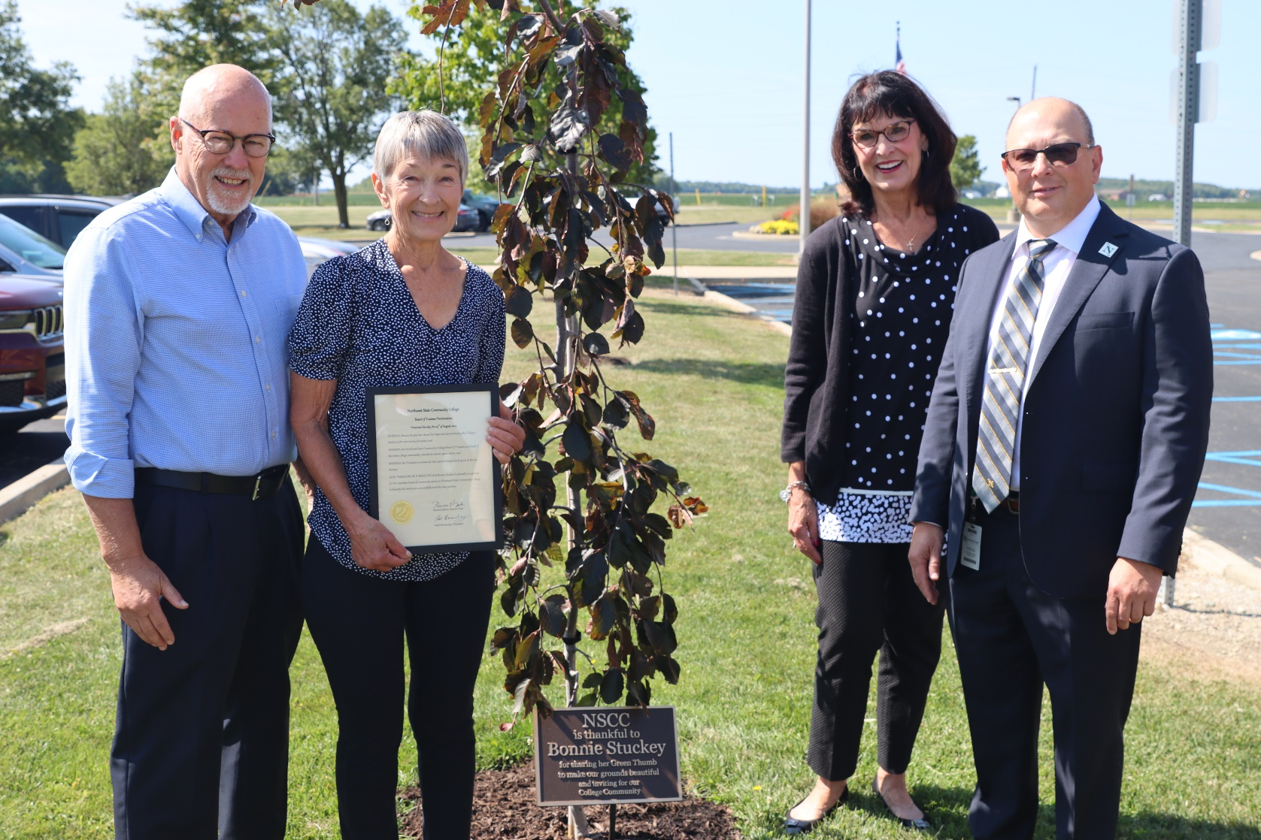

L to R: Dr. Tom Stuckey (NSCC President Emeritus), Bonnie Stuckey, Sandra Barber (NSCC Board of Trustees Chair), Dr. Todd Hernandez (NSCC President)