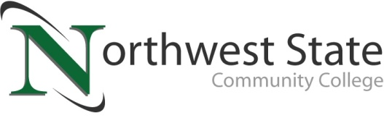

**DATE:** July 24, 2024

**CONTACT:** Jim Bellamy 419.267.1267 jbellamy@NorthwestState.edu

**NORTHWEST STATE COMMUNITY COLLEGE CENTER FOR LIFELONG LEARNING  
TO OFFER EXCURSION TO HAYES PRESIDENTIAL CENTER**

*Archbold, Ohio* – The NSCC Center for Lifelong Learning is offering a special same-day excursion to the Rutherford B. Hayes Presidential Library and Museums on Wednesday, September 18, 2024. The cost to participate is $135.00. The event is suitable for ages 12 and up.

The Hayes Presidential Library and Museums comprises the presidential library, the museum, which was renovated in 2016 with the installation of all new exhibit galleries, the 31-room Victorian home of Rutherford and Lucy Hayes, which was restored in 2012 to look as it did when Rutherford and Lucy lived there. The historic 1892 Sandusky County jail has ties to President Rutherford B. Hayes, the 1840s Dungeon located underneath the Sandusky County Courthouse and the Gallows Exhibition Hall featuring the gallows used for the last hanging in Sandusky County. Hear exciting stories of some of the colorful criminals that resided in the jail while learning the significance of this rare and historic structure.

**RESERVE YOUR SPOT TODAY!**

Register by Friday, August 16th to reserve your spot. The Motorcoach arrives at the NSCC Archbold campus at 7:30 a.m. on September 18th, and departs at 8:00 a.m. $20 meal money is provided as part of the excursion. The trip is scheduled to return to NSCC at 4:00 p.m. that day. To sign up today, call Deb Wikstrom at 419.944.6195, or email **lifelong@NorthwestState.edu**. For more information on the CFLL, and other upcoming programs, please visit **NorthwestState.edu/lifelong-learning**.

###

*Northwest State Community College is an accredited two-year, state-assisted institution of higher education that has served northwest Ohio since 1969. Northwest State is committed to providing a quality, affordable education with personal attention and small class sizes. The College offers associate degrees with numerous transfer options, short-term certificate programs, and workforce training programs designed to meet the needs of local businesses and industries. For more information, visit NorthwestState.edu or call 419.267.5511.*