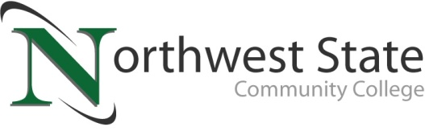

DATE: June 27, 2024
CONTACT: Jim Bellamy 419.267.1267 jbellamy@NorthwestState.edu

NINE COMPLETE LAW ENFORCEMENT ACADEMY AT NSCC

ARCHBOLD, OHIO – Nine graduates from the Northwest State Community College Law Enforcement Academy were honored last evening during a special ceremony. The class successfully completed both the state certification exam and the physical fitness requirements of the program. All nine graduates have also passed the 200-question Ohio Peace Officer Training Association (OPOTA) Certification examination, which is a requirement to become a law enforcement officer in the State of Ohio.

The following graduates were recognized:
Brianne Basilius (New Bavaria), Emilyanne Cox (West Unity), Ashlyn Figy (West Unity), Kelley Foor (Defiance), Zane Garber (Liberty Center), Austin Krueger (Toledo), Cole Niese (Leipsic), Isaiah Rittenhouse (Colverdale), Dillon Schwiebert (Holgate)

Several students from the graduating class received additional recognition:
Top Gun Award: Brianne Basilius
Top Driver Award: Dillon Schwiebert
Top Test Score Award: Cole Niese (97%)
Deputy Allen D. Ohlrich Outstanding Cadet Award: Emilyanne Cox

The Northwest State Community College Law Enforcement Academy is an eight-month program that is offered annually. Classes are held Monday through Friday from 5:00-10:00 p.m. and Saturdays from 8:00 a.m.-4:00 p.m. A new class is forming now and is scheduled to begin in August. For more information on the academy, contact the NSCC admissions team at 419.267.1320 or visit NorthwestState.edu online.

###

Northwest State Community College is an accredited two-year, state-assisted institution of higher education that has served northwest Ohio since 1969. Northwest State is committed to providing a quality, affordable education with personal attention and small class sizes. The College offers associate degrees with numerous transfer options, short-term certificate programs, and workforce training programs designed to meet the needs of local businesses and industries. For more information, visit NorthwestState.edu or call 419.267.5511.

MEDIA GALLERY LINK: https://northweststate.smugmug.com/20240626-NSCC-LEA-graduation-MEDIA
