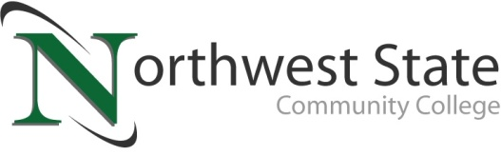

DATE: June 24, 2024
CONTACT: Jim Bellamy 419.267.1267 jbellamy@NorthwestState.edu

NORTHWEST STATE COMMUNITY COLLEGE FOUNDATION
PRESENTS $1,010,000 CHECK TO BOARD OF TRUSTEES

Archbold, Ohio – The Northwest State Community College Board of Trustees met in regular session on Friday, June 21st at the Archbold campus. After roll call, Robbin Wilcox, NSCC Executive Director for Development & NSCC Foundation and Foundation Board representative Kevin Whitlock presented the Board with a check in the amount of $1,010,000. The money is designated for student scholarships, equipment, outreach programs and student support efforts.

OVER $9 MILLION HAS BEEN PROVIDED…
Over $9 million has been provided through the generosity of businesses and individuals who have supported the Foundation over the past ten years. Kevin Whitlock, NSCC Foundation Board representative, applauded the generosity of individuals and businesses who have donated to the NSCC Foundation, for helping make this presentation possible. Whitlock also noted a special scholarship fundraising project underway for students in Fulton County, full details of which will be available soon.

FY ’25 BUDGET PASSES, AND MORE…
Another highlight of the Board meeting was the passage of the FY 2024-2025 budget. The total budget is just north of $45M, which represents an increase of approximately $10M from FY 2023-2024, with the majority of the increases going towards the completion of the renovation of B building and the College’s new Van Wert campus. The budget also includes increased scholarship awards, including the College Credit Plus textbook scholarship. NSCC President Dr. Todd Hernandez noted, "The new budget allocates funds for strategic initiatives that will continue to allow Northwest State Community College to serve northwest Ohio by improving lives and strengthening communities."

As part of the meeting, the Board also approved the ODHE Completion Plan, which is due to the Ohio Department of Higher Education on June 30, 2024, and requires Board approval.

In other Board action:
- Approved the promotion of Timothy Adalpe to Training Manager-Commercial Driver License program.
- Approved the employment of Brandon Dummitt as Training Coordinator-Commercial Driver License program, Kyrin Grime as Fundraising Coordinator, Abigail Roth as Recruiter-Admissions, Rachel Verville as Enrollment Specialist-Van Wert, and Chandra Gibbons as Administrative Assistant-Community & Workforce Development (Maumee).
- Approved the transition of Tamara Meyer to Nursing Program Coordinator.
- Approved a pay rate increase of 4% for part-time faculty, beginning Fall 2024 semester.
- Approved the end of the non-continuance of the Youth and Community Program Coordinator position, funded by Fulton County Job & Family Services, effective June 30, 2024.
- Accepted a 2016 Ford Taurus to the NSCC Law Enforcement Academy from the Paulding County Sheriff’s Office, with a value of $6,000.
- Approved program inactivation for the Quality Control Certificate program.
- Approved new Student Location Policy, in accordance with Title 34 CFR 668.43 (C) (3) (ii).
- Approved new Campus Safety & Security Policy.
- Approved an amended Reserves Policy.
- Approved miscellaneous employment contracts, one retirement and three resignations.

###

Northwest State Community College is an accredited two-year, state-assisted institution of higher education that has served northwest Ohio since 1969. Northwest State is committed to providing a quality, affordable education with personal attention and small class sizes. The College offers associate degrees with numerous transfer options, short-term certificate programs, and workforce training programs designed to meet the needs of local businesses and industries. For more information, visit NorthwestState.edu or call 419.267.5511.

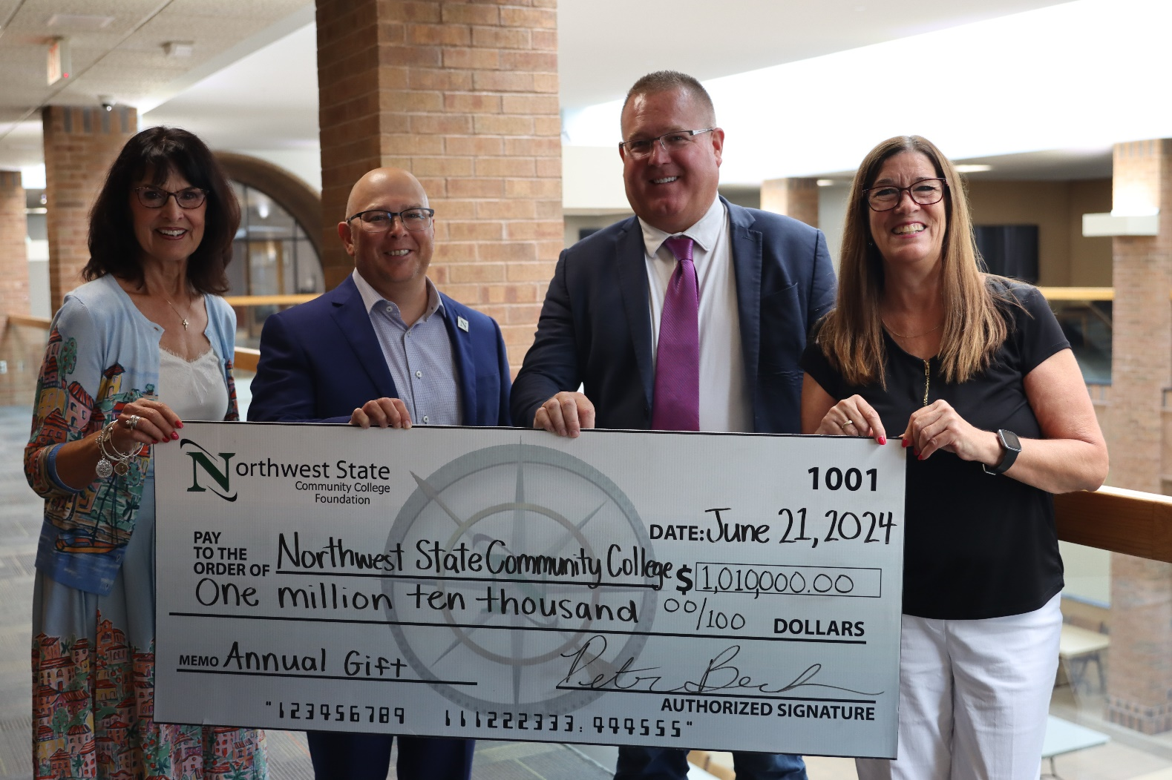

CAPTION: The NSCC Foundation presented a check to the NSCC Board of Trustees for $1,010,000 at the June 21, 2024 meeting. Pictured L to R: Sandra Barber (Chair, NSCC Board of Trustees), Dr. Todd Hernandez (NSCC President), Kevin Whitlock (representing the NSCC Foundation Board), and Robbin Wilcox (NSCC Executive Director of Development and Foundation).

