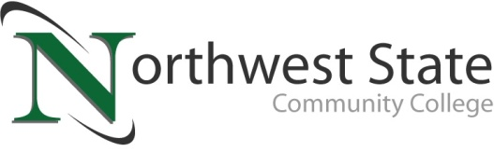

DATE: May 27, 2024
CONTACT: Jim Bellamy 419.267.1267 jbellamy@NorthwestState.edu

NORTHWEST STATE BUSINESS PROGRAMS ACCREDITED THROUGH 2025 BY
THE ACCREDITATION COUNCIL FOR BUSINESS SCHOOLS AND PROGRAMS (ACBSP)

Archbold, Ohio – Northwest State Community College business programs have been formally granted continuing accreditation through spring 2025 by the Accreditation Council for Business Schools and Programs (ACBSP). The decision comes from the ACBSP Board of Commissioners meeting in April 2024.

WHAT IT MEANS
ACBSP's accreditation process follows the Baldrige model. The accreditation focuses on recognizing teaching excellence, determining student learning outcomes, and a continuous improvement model. ACBSP’s student-centered teaching and learning approach, which is measured and analyzed for quality, ensures that students gain the right skills from their educational investment. Institutions with programs accredited by ACBSP are committed to continuous improvement that ensures their business program will give students the skills employers want.

From their website (ACBSP.org), the ACBSP is “a global business education accrediting body and the first organization to offer accreditation to all levels of collegiate business educational degree programs from associate to doctoral.”

Jason Rickenberg, NSCC Dean of Business and Public Services, remarked “Earning ACBSP accreditation is a gold standard for business programs; both nationally and globally. The quality and rigor of our business programs at NSCC is excellent, and our faculty do a tremendous job preparing students for the next steps in their journeys, whether it’s a great career opportunity, or additional education. Our division has worked very hard with our two-year quality assurance report, and we are continuing the work on our self-study this fall, in order to earn another 10 year award."

NSCC President Dr. Todd Hernandez added, “We are proud of our Business programs for continuing this prestigious accreditation through ACBSP. Program accreditation is critical to our success at NSCC, ensuring students receive the highest-quality education possible. We celebrate this announcement and invite students to come discover Northwest State today!”

Additional information on Northwest State Community College nursing programs, as well as all other degree and certificate programs, and the Bachelor’s Bound transfer pathway, are available at NorthwestState.edu.

###

Northwest State Community College is an accredited two-year, state-assisted institution of higher education that has served northwest Ohio since 1969. Northwest State is committed to providing a quality, affordable education with personal attention and small class sizes. The College offers associate degrees with numerous transfer options, short-term certificate programs, and workforce training programs designed to meet the needs of local businesses and industries. For more information, visit NorthwestState.edu or call 419.267.5511.

https://acbsp.org/page/accreditation-overview

