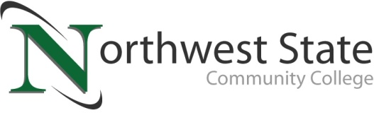

Date: May 6, 2024
Contact: Jim Bellamy | 419.267.1267 | jbellamy@northweststate.edu

NORTHWEST STATE RECOGNIZES POETRY AND PERFORMANCE CONTEST WINNERS

Archbold, Ohio – Every April, to commemorate National Poetry Month, the Northwest State Community College division of Arts and Sciences partners with Student Activities to bring about a celebration of poetry, art, and music. Students beat end-of-term stress with temporary tattoos, magnetic poetry, a juried art gallery, information about clubs and organizations, and plenty of snacks. This year’s festivities were centered around the theme of Speak. Easy and students were given the chance to participate in communal poetry projects, poetry workshops, an original poetry contest, and a 1920s Speakeasy themed performance contest. Prizes were awarded for both the writing of original poetry and for recitations of original or published poetry. NSCC students showcased the power of language and performance while at the same time kicking back for some well-deserved fun and entertainment.

Winners: Grace Torres (Original Poetry Winner)
Seth Snyder (Best Overall Performance)
Croyden Cardarelli (Honorable Mention Performance)
Drew Jackson (Honorable Mention Performance)
Izayah Nonnemacher (Honorable Mention Performance)

A big thank you to all learners, faculty, and staff who came out to read, listen, and cheer each other on. For more information on upcoming Northwest State Community College events, please visit NorthwestState.edu/events.

###
Northwest State Community College is an accredited two-year, state-assisted institution of higher education that has served northwest Ohio since 1969. Northwest State is committed to providing a quality, affordable education with personal attention and small class sizes. The College offers associate degrees with numerous transfer options, short-term certificate programs, and workforce training programs designed to meet the needs of local businesses and industries. For more information, visit NorthwestState.edu or call 419.267.5511.

CAPTION: NSCC Poetry and Performance contest winners from YAWPFest 2024 (L to R: Croyden Cardarelli, Seth Snyder, Drew Jackson, Grace Torres, Izayah Nonnemacher)
