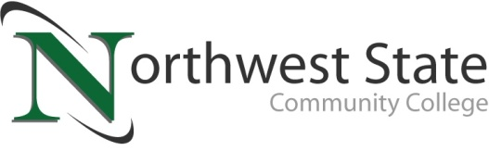

Date: April 28, 2023
Contact: Jim Bellamy | 419.267.1267 | jbellamy@northweststate.edu

NORTHWEST STATE RECOGNIZES POETRY CONTEST WINNERS

Archbold, Ohio – Every April, to commemorate National Poetry Month, the Northwest State Community College division of Arts and Sciences partners with Student Activities to bring about a three day celebration of poetry, art, and music. Students beat end-of-term stress with temporary tattoos, magnetic poetry, a juried art gallery, information about clubs and organizations, and plenty of snacks. This year, the Open Mic spoken word contest coincided with National Pretzel Day, making for a lively event in the OASIS. Faculty and staff kicked off the open mic and then learners took the stage. Prizes were awarded for both original works and recitations of published poetry. The power or language and creativity provides just the spark to propel our learners to the last week of classes and exams.

Winners: 1st place: Kally Durham "Where I'm From" (original poem)
2nd place: Jayne Durham "Post-It Note Monologues" (original poem)
3rd place: Izayah Nonnenmacker "Harlem" (Langston Hughes)

A big thank you to all learners, faculty, and staff who came out to read, listen, and cheer each other on. For more information on upcoming Northwest State Community College events, please visit NorthwestState.edu/events.

###
Northwest State Community College is an accredited two-year, state-assisted institution of higher education that has served northwest Ohio since 1969. Northwest State is committed to providing a quality, affordable education with personal attention and small class sizes. The College offers associate degrees with numerous transfer options, short-term certificate programs, and workforce training programs designed to meet the needs of local businesses and industries. For more information, visit NorthwestState.edu or call 419.267.5511.

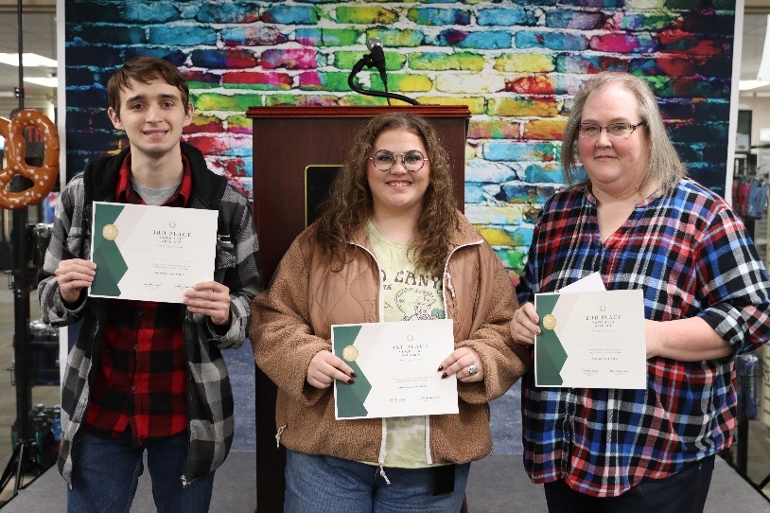
CAPTION: NSCC poetry contest winners from YAWPFest 2023 (L to R: Nonnenmacker, K Durham, J Durham)

