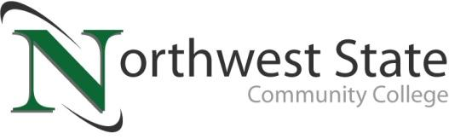

DATE: April25, 2024
CONTACT: Jim Bellamy, jbellamy@northweststate.edu or 419.267.1267

NORTHWEST STATE TO HOST GAME CON,
A GAMING AND POP CULTURE CONVENTION

ARCHBOLD, OHIO – Northwest State Community College will be hosting Game Con, “the premier pop culture convention held by NSCC Thunder (the College’s official Esports team) and Northwest State Community College,” on Saturday, June 22nd from 11:00 a.m. to 8:00 p.m. The event is free to attend, and all ages are welcome.

Game Con will host a multitude of events and competitions. They include a 64-player Super Smash Bros. Ultimate Tournament with a $600 prize pool, a Pokémon Card Game Tournament with a $200 prize pool, a Cosplay Contest with a $400 prize pool, and a Beyblade Burst tournament and a LEGO Build Competition with various item prizes.

PLENTY OF ACTIVITIES AVAILABLE…
Some of the non-tournament activities that day are scheduled to include:
- Artist Alley, Vendors, and Authors
- Cosplay and Dungeons & Dragons panels
- Costume and Cosplay contest and activities
- Open console play with Nintendo Switches, PlayStations, and many other consoles
- Food and Ice Cream trucks
- Door prizes, Open LEGO build stations, VR Stations, and much more!

ADDITIONAL INFORMATION…
Additional information, including pre-registration links, photos, etc., are available at NorthwestState.edu/GameCon. Follow NSCC Thunder on social media at Instagram.com/NSCCThunder, Twitter.com/NSCCThunder, and Facebook.com/NSCCThunder for more information about vendors, events, and other Game Con news.
###

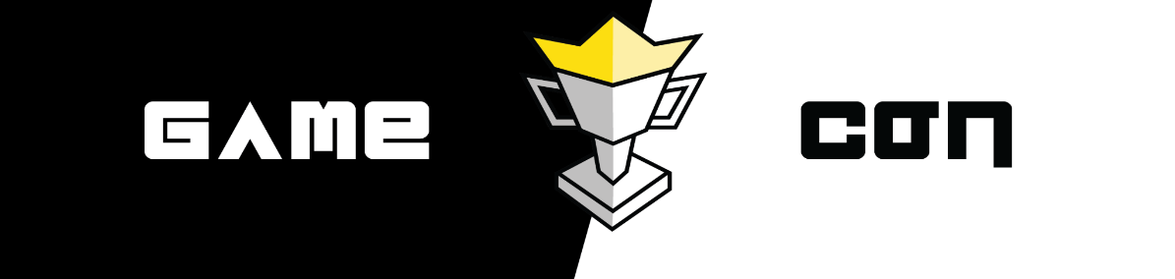
Northwest State Community College is an accredited two-year, state-assisted institution of higher education that has served northwest Ohio since 1969. Northwest State is committed to providing a quality, affordable education with personal attention and small class sizes. The College offers associate degrees with numerous transfer options, short-term certificate programs, and workforce training programs designed to meet the needs of local businesses and industries. For more information, visit NorthwestState.edu or call 419.267.5511.

