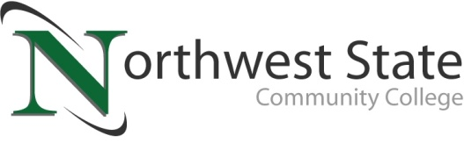

DATE: April 13, 2023
CONTACT: Jim Bellamy 419.267.1267 jbellamy@NorthwestState.edu

NSCC RECEIVES $139,167 OHIO DEPT. OF HIGHER EDUCATION GRANT
FOR COMMERCIAL TRUCK DRIVER STUDENT AID

Archbold, Ohio – Northwest State Community College received a grant from the Ohio Department of Higher Education (ODHE) in the amount of $139,167 for the Commercial Truck Driver Student Aid Program. A total of $2.5 million was awarded in this round of funding.

ABOUT THE INITIATIVE
Per the original confirmation letter dated March 22, 2023 from Chancellor Randy Gardner at the ODHE, the grant provides “critical financial aid to in-state students who complete a CDL program and agree to reside and be employed in Ohio for a minimum of one year upon completion. (Students) who earn a CDL with this award will help strengthen and grow this high-demand occupation and improve job growth for Ohio’s commercial drivers.”

HOW IT WILL BE ADMINISTERED
The Grant / Loan program provides eligible Ohio residents the opportunity to complete their federally mandated Class A Entry Level Driver Training Program without having to pay any amount of the cost out of pocket initially. If an individual taking advantage of the program then utilizes their CDL to work for an Ohio based employer (full time, part time, or self-employed) for a duration of 12 months, their loan will then be eligible for complete forgiveness, effectively bringing the out of pocket program cost to $0.00. This is the second round of funding that Northwest State has been awarded for this specific program. Last round, every single dollar of funding awarded was utilized to completely fund the program cost of 17 Ohio residents. With an increased total award amount this round, Northwest State is on track to fully fund another 20 students this year.

The CDL Training Center, Powered by Custom Training Solutions (CTS), has a federally registered Entry Level Driver Training program starting roughly every other week at the NSCC Archbold Campus. The program is designed to generate safety conscious drivers, while also providing more than just the necessary training needed to pass a CDL driver’s licensing exam. Last year, the NSCC CDL Training Center had an overall passing rate of 94%. The result of this effort was the addition of 30 new drivers to our local area. With a ramp up in course offerings this calendar year, Northwest State is currently on track to serve approximately 82 students this calendar year. For more information on the CDL program, please visit NorthwestState.edu/cdl or call 419.267.1332 today.

###
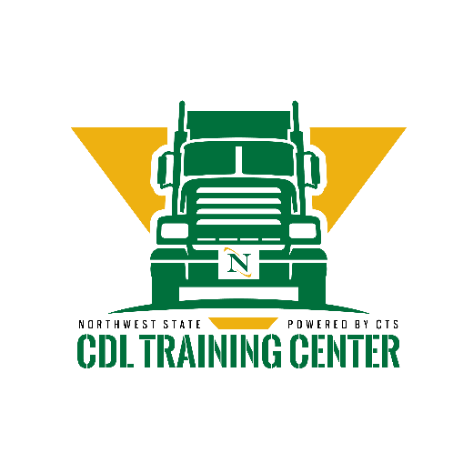
Northwest State Community College is an accredited two-year, state-assisted institution of higher education that has served northwest Ohio since 1969. Northwest State is committed to providing a quality, affordable education with personal attention and small class sizes. The College offers associate degrees with numerous transfer options, short-term certificate programs, and workforce training programs designed to meet the needs of local businesses and industries. For more information, visit NorthwestState.edu or call 419.267.5511.

