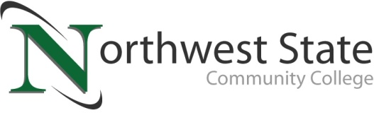

DATE: March 29, 2023
CONTACT: Jim Bellamy 419.267.1267 jbellamy@NorthwestState.edu

northwest state community college-led teams advance to
state first robotics competition

Archbold, Ohio – The Northwest State Community College FIRST Robotics high school team 6181 (Cryptic Cyborgs) will compete at the 2023 Buckeye Regional tournament held at Cleveland State University – Wolstein Center, March 30 through April 1, 2023. Teams from Ohio, New York, Pennsylvania, Wisconsin, Illinois and Kentucky will compete at the event. The Northwest State Community College team members are from local high schools in northwest Ohio, including Bryan, Delta, Fairview, Liberty Center, Wauseon, Pettisville, and Four County Career Center.

LOCAL SUPPORT
Jim Drewes, Vice President for Workforce Development at NSCC (and Cryptic Cyborgs advisor) noted “We are excited to compete with some tremendous teams across the region. Our students have been amazing, applying valuable STEM principles and having a great time, all while preparing for this competition.” NSCC President Dr. Todd Hernandez offered his congratulations and best wishes, noting “Our Cryptic Cyborgs team is a tremendous representation of Northwest State Community College and northwest Ohio. We wish them the best of luck!”

ABOUT FIRST ROBOTICS
FIRST Robotics Competition combines the excitement of sport with the rigors of science and technology, with competitions held nationwide, and around the world. From the official Buckeye Regional website, “The overall goal of the competition is to engage students in an engineering project to design, build, test, and operate a robot which would encourage them to pursue careers in Science, Technology, Engineering, and Mathematics (STEM).” Additional information is available at https://sites.google.com/view/frcbuckeye/home. To watch the competition on Twitch, go to Twitch.tv/firstinspires7 and Twitch.tv/firstinspires8.

###

Northwest State Community College is an accredited two-year, state-assisted institution of higher education that has served northwest Ohio since 1969. Northwest State is committed to providing a quality, affordable education with personal attention and small class sizes. The College offers associate degrees with numerous transfer options, short-term certificate programs, and workforce training programs designed to meet the needs of local businesses and industries. For more information, visit NorthwestState.edu or call 419.267.5511.

