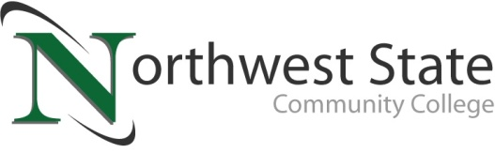

DATE: February 2, 2023
CONTACT: Jim Bellamy 419.267.1267 jbellamy@NorthwestState.edu

NORTHWEST STATE COMMUNITY COLLEGE CENTER FOR LIFELONG LEARNING
TO PRESENT PROGRAM ON RUTHERFORD B. HAYES

Archbold, Ohio – Kevin Moore is the Curator of Artifacts at the Rutherford B. Hayes Presidential Library and Museums in Fremont, Ohio. He is responsible for caring for the museum’s collection of 20,000+ objects and designing its annual rotating exhibits. A graduate of the MA history program at BGSU, Kevin has also taught American History at Northwest State Community College for 10 years. Moore will be presenting about the life and administration of the nation’s 19th president, Rutherford B. Hayes on Friday, February 17 in room C200.

Adults 50 and over are invited to attend a special program, presented by the NSCC Center for Lifelong Learning (CFLL) at the Archbold Campus on Friday, February 17 in room C200. Breakfast will begin at 9:00 a.m. through 11:30 a.m., and Mr. Moore will present beginning at approximately 10:15 a.m. There is a $12 charge per person to attend.

TO SAVE YOUR SPOT, AND FOR MORE INFORMATION…
Reservations are now being accepted for this special CFLL program, by calling Deb Wikstrom at 419.944.6195, or by email at dwikstrom@NorthwestState.edu. For more information on the CFLL, and other upcoming programs, please visit NorthwestState.edu/lifelong-learning.

###

Northwest State Community College is an accredited two-year, state-assisted institution of higher education that has served northwest Ohio since 1969. Northwest State is committed to providing a quality, affordable education with personal attention and small class sizes. The College offers associate degrees with numerous transfer options, short-term certificate programs, and workforce training programs designed to meet the needs of local businesses and industries. For more information, visit NorthwestState.edu or call 419.267.5511.

