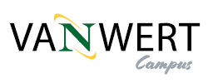
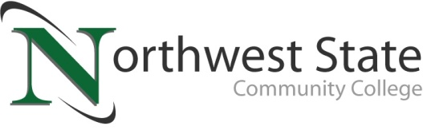

DATE: January 29, 2024
CONTACT: Jim Bellamy 419.267.1267 jbellamy@NorthwestState.edu

NORTHWEST STATE COMMUNITY COLLEGE TO OFFER
“FIRST CLASS FREE” SCHOLARSHIP AT VAN WERT CAMPUS

van wert, Ohio – Northwest State Community College is excited to offer an innovative “first class free” scholarship for Paulding and Van Wert county (and surrounding area) learners to its Van Wert campus. This announcement comes as the Van Wert full-service campus is currently undergoing demolition and renovation at the former Kennedy Manufacturing building. Our inaugural scholarship is made possible from funds raised locally through golf outings, NSCC
Foundation events, and other NSCC endeavors. Foundation Executive Director Robbin Wilcox is excited to partner with Van Wert and Paulding to raise the needed dollars to assist local students with scholarship opportunities.

UTILIZING FUNDS RAISED LOCALLY
Fundraising efforts from the NSCC Foundation have been ongoing for the past few years, with the major fundraiser being the NSCC Van Wert Campus golf outing, held at Hickory Sticks in Van Wert. Danfoss has been the title sponsor since the event’s inception, and their dedication to the school and the community is vital to the College’s ongoing efforts. “Danfoss sees the value in supporting Northwest State in their efforts to build a full-service campus in Van Wert. We appreciate the opportunity to play a part in the fundraising efforts, giving back to students, and to the community,” Wade Adamson, Senior Director of Operations at Danfoss, said. NSCC has raised a total of $35,000 through the golf outings.

HOW THE SCHOLARSHIP WORKS
The Van Wert “first class free” scholarship is for newly-admitted NSCC students for the Fall 2024 semester, and they must live within Paulding, Van Wert, or Putnam county OR live in a surrounding county and have previously taken courses through NSCC as a College Credit Plus student. A maximum of 50 Van Wert Scholarships will be awarded, and it’s on a first-come, first-served basis to qualifying students. This is a tuition-only scholarship; technology, textbooks and other fees will still apply. Full details, including the scholarship application link, are available now at NorthwestState.edu/VanWert.

FOR MORE INFORMATION
NSCC continues to offer classes temporarily in Van Wert at Van Wert Hospital, as well as online, while the Van Wert Campus undergoes demolition and renovation. The College will also endeavor to regularly document building progress via NSCC social media, as well as online at NorthwestState.edu/VanWert.

###

Northwest State Community College is an accredited two-year, state-assisted institution of higher education that has served northwest Ohio since 1969. Northwest State is committed to providing a quality, affordable education with personal attention and small class sizes. The College offers associate degrees with numerous transfer options, short-term certificate programs, and workforce training programs designed to meet the needs of local businesses and industries. For more information, visit NorthwestState.edu or call 419.267.5511.

