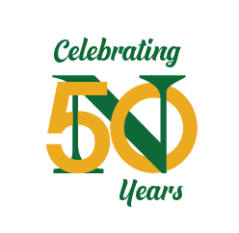
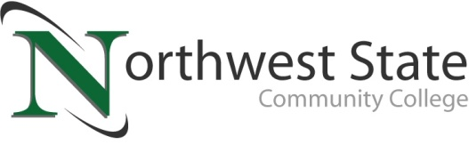

Date: April 16, 2021
Contact: Jim Bellamy | 419.267.1267 | jbellamy@northweststate.edu

NSCC FOUNDATION AWARDS $843,000 in scholarships

Archbold, Ohio –The Northwest State Community College Foundation proudly awarded $843,000 in scholarships to 278 students from the region. The total dollars awarded shatters last year’s record totals, offering needed financial help to students through the generosity of donors to the NSCC Foundation.

On Thursday, April 15th, the College premiered a virtual reception, to celebrate the accomplishments of the students and offer gratitude for the support of local donors.

“COVID-19 may have kept us from meeting in person again this year, but the Foundation was once again determined to put a proper celebration together,” said Robbin Wilcox, Executive Director of Development & the NSCC Foundation. “We wanted to make sure our learners knew how proud we are of their amazing accomplishments, and we wanted our generous donors to know how grateful we are for their support. It is through their generosity that these scholarships exist,” Wilcox noted.

VIRTUAL RECEPTION
Due to COVID-19, the Scholarship Awards Reception was held as a pre-recorded, virtual reception which premiered April 15th on the NorthwestState.edu/live webpage. Elements of the video were filmed at the NSCC Archbold campus, as well as other locations throughout northwest Ohio. The event kicked off with opening remarks by NSCC President Todd Hernandez and NSCC Foundation Board Chair Peter Beck, each providing congratulatory remarks to both students and gratitude to the donors who make the scholarships possible.

DONOR AND STUDENT PERSPECTIVES
Ron Coles, NSCC Alumni Association President, provided the donor perspective, noting “A Northwest State education counts and will forever be life-changing.” Pamela Stephey, a 2020 NSCC Phlebotomy graduate currently working to complete her Medical Assisting degree, and a Phlebotomist at ProMedica Defiance Regional Hospital, provided the student perspective. “I hope one day I will also be able to help struggling students reach their goals in higher education by assisting them in the same way (donors) are helping me today,” she said. Stephey is a Francis O. Fackler Scholarship recipient.

ABOUT THE NSCC FOUNDATION
The NSCC Foundation was established in 1978 to provide support for the students, people and programs of NSCC. For over 40 years, the Foundation has remained true to its mission to enhance, expand and sustain Northwest State so that NSCC can continue to fulfill its mission of creating opportunities for transformational learning. The NSCC Foundation works diligently to raise much-needed funds for educational opportunities that directly and indirectly impact students. “The NSCC Foundation continues to work hard each year to increase funding to support our students through both scholarships and efforts to provide state of the art training equipment,” noted Wilcox. She added, “The NSCC Foundation is not only giving more scholarship dollars than ever before, they are also helping the College to develop and expand programs that will help both students and our business partners for generations to come.” Additional information about the NSCC Foundation is available at NorthwestState.edu/foundation.

###
Northwest State Community College is an accredited two-year, state-assisted institution of higher education that has served northwest Ohio since 1969. Northwest State is committed to providing a quality, affordable education with personal attention and small class sizes. The College offers associate degrees with numerous transfer options, short-term certificate programs, and workforce training programs designed to meet the needs of local businesses and industries. For more information, visit NorthwestState.edu or call 419.267.5511.

PLEASE NOTE: A FULL LIST OF SCHOLARSHIP RECIPIENTS IS INCLUDED AS AN EXCEL LIST IN THE EMAIL SENT TO MEDIA –JCB. THE EVENT PROGRAM, WHICH INCLUDES DONORS AND RECIPIENTS, AS WELL AS THE EVENT VIDEO, CAN BE FOUND ONLINE AT
NORTHWESTSTATE.EDU/SCHOLARSHIP-RECEPTION.

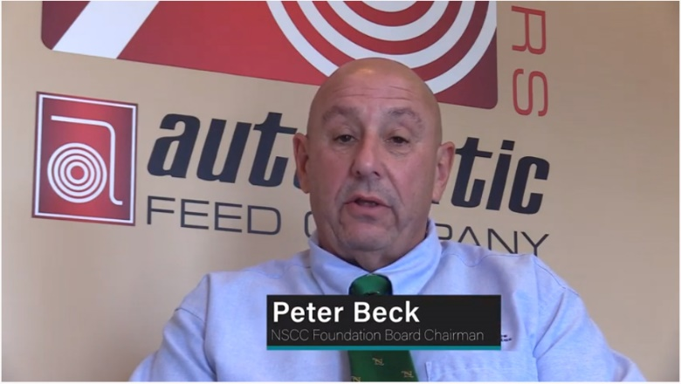
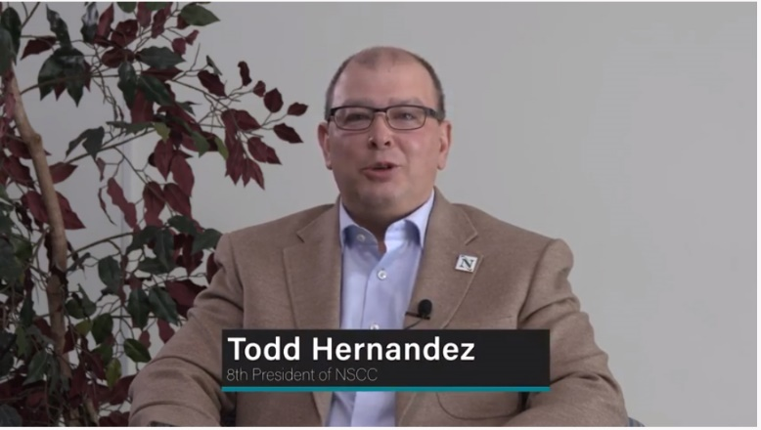
Photos: Photos from the 2021 Northwest State Community College Foundation Scholarship Awards Reception, held as a pre-recorded, virtual event April 15th. A record $843,000 in scholarships was awarded to 278 students.
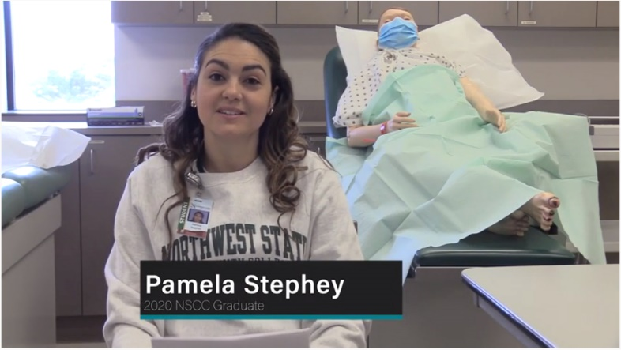
Image 1: NSCC President Todd Hernandez. Image 2: NSCC Foundation Board Chair, Peter Beck. Image 3: Pamela Stephey, 2020 NSCC Phlebotomy graduate.

