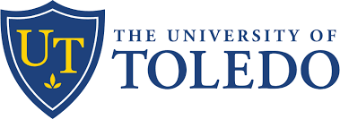
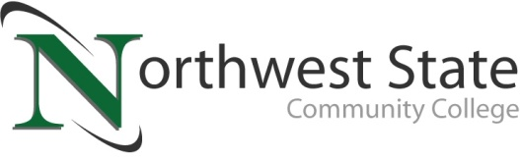

DATE: September 20, 2023
CONTACT: Jim Bellamy 419.267.1267 jbellamy@NorthwestState.edu
Nicki Gorny 419.530.2077 nicole.gorny@utoledo.edu

NEW TRANSFER AGREEMENT PROVIDES PATHWAY FOR
NORTHWEST STATE GRADUATES TO ATTEND UTOLEDO

Archbold, Ohio – The University of Toledo and Northwest State Community College are partnering to create a seamless pathway for students to earn a bachelor’s degree from UToledo after starting at Northwest State.

The Rocket Transfer Admission Pathway formalizes a long-standing relationship between the two institutions. It makes UToledo advisors available to students pursuing an associate degree at Northwest State, paving the way for graduates to continue their educations with a bachelor’s degree program at UToledo. It also opens a door to future opportunities for these students at UToledo.

“Northwest State is pleased to enter this affiliation agreement with The University of Toledo. Many of our learners wish to continue their education beyond a two-year degree, and NSCC is pleased to help facilitate this great transfer opportunity,” said Dr. Todd Hernandez, President of Northwest State Community College. “Our faculty does a tremendous job both in preparing learners to enter directly into the workforce and to continue their education at great four-year institutions. This agreement with UToledo is a shining example of our ongoing efforts to elevate Northwest Ohio through the power of a great education.”

“We are proud to partner with Northwest State Community College on the Rocket Transfer Admission Pathway because transfer students enrich our campus community at UToledo,” said UToledo President Gregory Postel. “We look forward to welcoming Northwest State students to our campus and supporting them in achieving their educational goals to obtain a bachelor’s degree.”

About Northwest State Community College
Northwest State Community College is an accredited two-year, state-assisted institution of higher education that has served northwest Ohio since 1969. Northwest State is committed to providing a quality, affordable education with personal attention and small class sizes. The College offers associate degrees with numerous transfer options, short-term certificate programs, and workforce training programs designed to meet the needs of local businesses and industries. For more information, visit NorthwestState.edu or call 419.267.5511.

About The University of Toledo
For 150 years, The University of Toledo has been fueling tomorrows through education, research and discovery, patient care and economic development. As a public research university and academic medical center located in Toledo, Ohio, UToledo is a community of scholars committed to empowering our students and engaging our regional, state, national and global communities to improve the human condition – today and for the future. Learn more at utoledo.edu.

###

