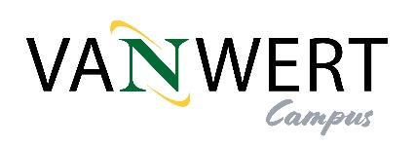
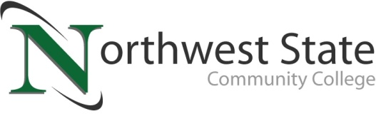

DATE: August 28, 2023
CONTACT: Jim Bellamy 419.267.1267 jbellamy@NorthwestState.edu

NORTHWEST STATE COMMUNITY COLLEGE RECEIVES UPDATES
ON VAN WERT CAMPUS RECRUITMENT AND FUNDRAISING EFFORTS

Archbold, Ohio – The Northwest State Community College Board of Trustees met in regular session on Friday, August 25th at the Archbold campus. As part of the meeting, the Board received an update on the Van Wert campus, including ongoing recruitment and fundraising efforts in Van Wert and Paulding counties, as the College begins the process of renovating the former Kennedy Manufacturing facility in Van Wert to eventually become a full-service campus.

IMPORTANT WORK HAPPENING IN PAULDING & VAN WERT COUNTIES
A panel of NSCC employees, including the Dean of the Van Wert Campus Dr. Jon Tomlinson, Executive Foundation Director Robbin Wilcox, and Marketing & Communications Manager Jim Bellamy, presented the ongoing activities related to student recruitment (PR and advertising) and fundraising. Dr. Tomlinson noted the confirmed articulation agreements with area four-year schools, Wilcox shared information on the numerous events/sponsorships and memberships in both counties, and Bellamy discussed the depth of marketing already taking place in the two counties (digital marketing, print, radio and billboards were mentioned).

The presentation concluded with NSCC CFO Jenny Thome and Facilities Director Kevin Gerken sharing construction updates, including cost estimates and current status of the campus renovation project. A Construction Manager will be announced the week of August 28th, and a special date will be set for the initial Agreement.

NSCC IS THE #1 COMMUNITY COLLEGE IN OHIO
NSCC President Dr. Todd Hernandez shared the recent news about the WalletHub best community colleges study, with NSCC being ranked the #1 community college in Ohio. Board Chair Scott Mull congratulated the College for this recognition, noting the great work done by faculty, staff, and administration to help guide learner success.

In other Board action:
- Approved the promotion of Susan Cheeseman to Director-Grants Development, Vickie Rhodes to Agency manager, Heidi Keller to Coordinator-Accreditation, and Renee Bostelman to Academic Pathways Coordinator.
- Approved the employment of Greg Smith as Interim Commander-Law Enforcement Academy, Daniel Robarge as Maintenance Technician, Keri Eason as Director-Institutional Research, Lindsay Folkerth as Faculty-Composition, Chelsie Ebaugh as Faculty-Composition, and Jose Silva as Admissions Recruiter.
- Approved tuition rates for the 2023-2024 academic year (in-state: $192.33, out-of-state $378.66).
- Approved using scholarship funds to offset the $5 per credit hour increase, so as to not pass the expense on to learners for the spring 2024 semester.
- Approved a new Weapons Policy (following all state and federal laws pertaining to weapons, including section 2923.122 of the Ohio Revised Code).
- Approved miscellaneous employment contracts, as well as six resignations.

###

Northwest State Community College is an accredited two-year, state-assisted institution of higher education that has served northwest Ohio since 1969. Northwest State is committed to providing a quality, affordable education with personal attention and small class sizes. The College offers associate degrees with numerous transfer options, short-term certificate programs, and workforce training programs designed to meet the needs of local businesses and industries. For more information, visit NorthwestState.edu or call 419.267.5511.

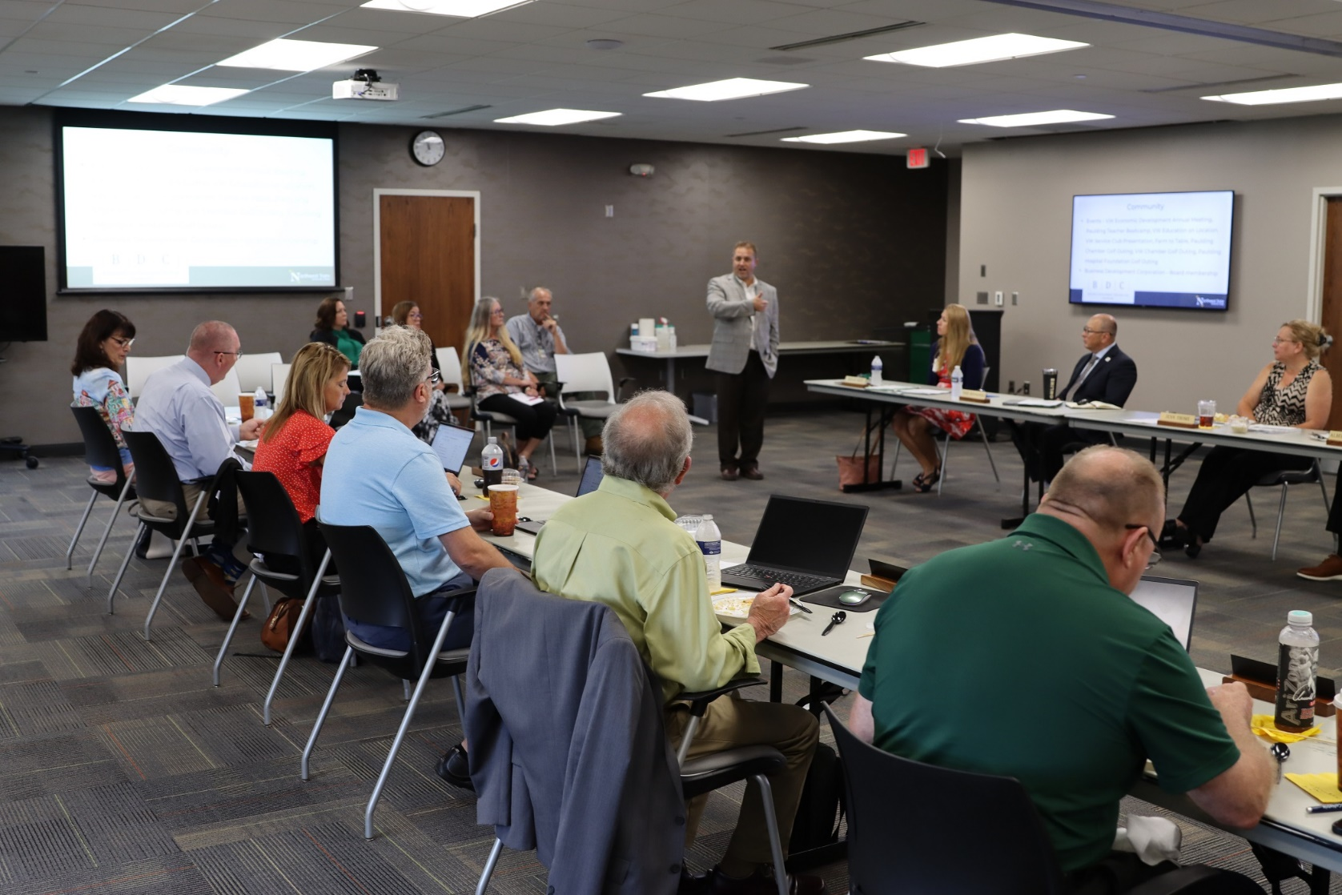

CAPTION: Dr. Jon Tomlinson (NSCC Dean of Van Wert Campus, center), presents to the Board of Trustees at the 8/25/2023 meeting.

