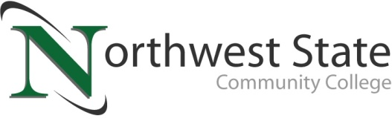

DATE: May 9, 2023
CONTACT: Jim Bellamy 419.267.1267 jbellamy@NorthwestState.edu

NORTHWEST STATE COMMUNITY COLLEGE CENTER FOR LIFELONG LEARNING
TO OFFER TOUR OF DEFIANCE LIBRARY AND TUTTLE MUSEUM

Archbold, Ohio – The NSCC Center for Lifelong Learning is offering its first off-campus visit to the Defiance County Library (320 Fort St.) and the Andrew L. Tuttle Memorial Museum in Defiance, OH on Wednesday, May 24th. The meeting time will be 10:00 a.m. at the Defiance County Library for a tour of the library, the historical grounds, and then a trip to the Tuttle Museum. Please note: no transportation will be provided.

From the museum, the group will be traveling to Kingsbury Park (118 Auglaize St. in Defiance) for a boxed lunch. Cost for this is just $10 per person. Comfortable clothing and shoes are recommended as they will be walking the short distance to the Tuttle Museum from the library.

TO SAVE YOUR SPOT, AND FOR MORE INFORMATION…
Reservations are now being accepted for this special CFLL program, by calling Deb Wikstrom at 419.944.6195, or by email at lifelong@NorthwestState.edu. For more information on the CFLL, and other upcoming programs, please visit NorthwestState.edu/lifelong-learning.

###

Northwest State Community College is an accredited two-year, state-assisted institution of higher education that has served northwest Ohio since 1969. Northwest State is committed to providing a quality, affordable education with personal attention and small class sizes. The College offers associate degrees with numerous transfer options, short-term certificate programs, and workforce training programs designed to meet the needs of local businesses and industries. For more information, visit NorthwestState.edu or call 419.267.5511.

