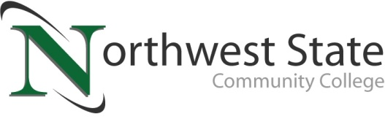

DATE: April 22, 2024
CONTACT: Jim Bellamy 419.267.1267 jbellamy@NorthwestState.edu

NORTHWEST STATE COMMUNITY COLLEGE BOARD OF TRUSTEES
APPROVE NEW PROGRAMS

Archbold, Ohio – The Northwest State Community College Board of Trustees met in regular session on Friday, April 19th at Fulton County Health Center (Beck Meeting Room) in Wauseon, at 9:00 a.m. The early start allowed the Board of Trustees to hold their scheduled spring retreat in the afternoon at the same location.

As part of the meeting, the Board approved the following short-term certificates and one-year certificates: Entrepreneurship certificate, Marketing certificate, Automation short-term certificate, CAM short-term certificate, Medical Coding & Billing Specialist short-term certificate, and Semiconductor Manufacturing short-term certificate. These programs help provide a vital employment pathway to businesses in our region.

TUITION INCREASE, AND EQUAL SCHOLARSHIP ASSISTANCE!
The Board also approved new tuition rates for the 2024-2025 academic year, which begins July 1, 2024. Spring 2025 semester tuition will see a $5 per credit hour increase to $197.33 for in-state students, and $191.33 for out-of-state students (with a total fee for out-of-state students becoming $388.66). The next agenda item, which was also approved, was a scholarship to nullify the $5 tuition increase per credit hour, to ensure the added costs are not passed on to students.

In other Board action:
- Approved the promotion of Cassie Rickenberg to Vice President-Enrollment Management and Student Affairs, Brittany Thompson to Executive Director-Enrollment Management, Shannon Floyd to Executive Director-Learner Services, and Renee Bostelman to Director-Advising.
- Approved the appointment of Dr. Dan Burklo to Associate Vice President-Strategic Initiatives.
- Approved the transfer of Dr. Lana Snider to Vice President-Academics, Tom Plummer to Senior Training Coordinator (CTS), and Tom Kelly to Training Manager of Manufacturing (CTS).
- Approved miscellaneous employment contracts.
- Approved two resignations and one retirement.

###

Northwest State Community College is an accredited two-year, state-assisted institution of higher education that has served northwest Ohio since 1969. Northwest State is committed to providing a quality, affordable education with personal attention and small class sizes. The College offers associate degrees with numerous transfer options, short-term certificate programs, and workforce training programs designed to meet the needs of local businesses and industries. For more information, visit NorthwestState.edu or call 419.267.5511.

