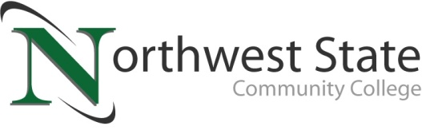

Date: January 8, 2024
Contact: Jim Bellamy, 419.267.1267 jbellamy@NorthwestState.edu

NORTHWEST STATE COMMUNITY COLLEGE ESPORTS TEAM
FALL 23 SEASON RESULTS

ARCHBOLD, OHIO –Esports continues to grow worldwide popularity, and Northwest State has continued to be a strong contender. The Northwest State Community College Esports team – NSCC Thunder – competed in the NACE conference during the fall semester.

WHAT IS NACE?
NACE is the National Association of Collegiate Esports, and is the largest collegiate Esports league in North America, facilitating competition for over 18,000 students from nearly 800 colleges and universities.

NACE requires students to be full-time, meaning they take 12 credit hours per semester. The NSCC Thunder team participated in Smash Bros. Ultimate and Overwatch 2 in the NACE conference.

RESULTS FROM FALL 2023
The Smash Bros. Ultimate team competed against universities such as Akron, Atlantic, and George Washington. They ended tied with 4 other teams for 39th out of 83 total teams. The Overwatch 2 team competed against universities such as North Alabama, Rochester and Missouri Southern. They ended tied 14th out of 185 teams being in the top 8% of teams.

ABOUT NSCC THUNDER...
NSCC Thunder has 10 Students participating across all the NACE Conference teams. NWO Gamers and NSCC Thunder also collaborate to host events that see regular attendance of 25+ people and share a Discord server with over 120 members across the community. Additional information on NSCC Esports is also available by emailing esports@NorthwestState.edu, or checking out northweststate.edu/esports.

###

Northwest State Community College is an accredited two-year, state-assisted institution of higher education that has served northwest Ohio since 1969. Northwest State is committed to providing a quality, affordable education with personal attention and small class sizes. The College offers associate degrees with numerous transfer options, short-term certificate programs, and workforce training programs designed to meet the needs of local businesses and industries. For more information, visit NorthwestState.edu or call 419.267.5511.
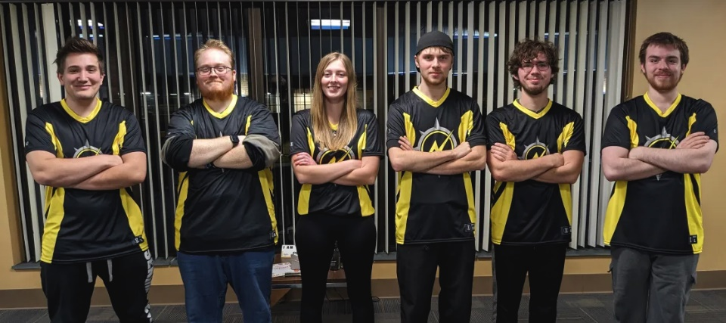

L to R: Jaden Bowers (West Unity), Derek Gribler (Napoleon), Cassie VanDyke (Marysville), Jared Christenson, Doug Nienberg (Holgate), David Breece (Hamler), and Bryson Hicks (Antwerp) (unpictured)

