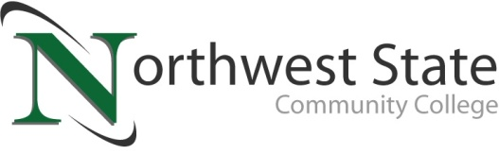

DATE: August 14, 2023
CONTACT: Jim Bellamy 419.267.1267 jbellamy@NorthwestState.edu

MEDIA ALERT

NSCC TO HOST 3ND ANNUAL VAN WERT CAMPUS GOLF OUTING
Friday, September 15, at Hickory Sticks Golf Club

Archbold, Ohio –

Who: Media representatives from Paulding & Van Wert Counties

What: NSCC will host its 3nd Annual Van Wert Campus Golf Outing, presented by Danfoss

When: Friday, September 15, 2023 at Hickory Sticks Golf Club (12083 US 127 in Van Wert)

misc: Proceeds from the NSCC golf outing will benefit Van Wert and Paulding County students attending Northwest State Community College. Following the golf outing (9:00 a.m. shotgun start), there will be a luncheon at the course. During the luncheon, NSCC President Dr. Todd Hernandez and Wade Adamson of Danfoss will provide some Van Wert updates. Dr. Hernandez will be available after his presentation for Q&A. Additional information on the golf outing is available at https://northweststate.edu/golf.

###
Northwest State Community College is an accredited two-year, state-assisted institution of higher education that has served northwest Ohio since 1969. Northwest State is committed to providing a quality, affordable education with personal attention and small class sizes. The College offers associate degrees with numerous transfer options, short-term certificate programs, and workforce training programs designed to meet the needs of local businesses and industries. For more information, visit NorthwestState.edu or call 419.267.5511.

