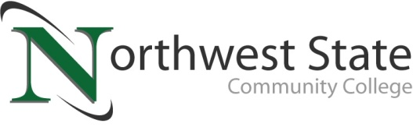

DATE: August 2, 2023
CONTACT: Jim Bellamy 419.267.1267 jbellamy@NorthwestState.edu

NORTHWEST STATE COMMUNITY COLLEGE CENTER FOR LIFELONG LEARNING
TO HOST “SUSTAINABLE FARMING PRACTICES” PRESENTATION

Archbold, Ohio – The NSCC Center for Lifelong Learning is offering a special presentation on sustainable farming practices, featuring a representative from The Ohio State University College of Food, Agriculture, and Environmental Sciences. The program, titled “Sustainable Farming Practices and How They Benefit the Environment and Water Quality” will be held at Northwest State on Friday, August 11th from 9:00 a.m. to noon in room C200.The cost to attend this event is $12.00.

FEATURED SPEAKER INFORMATION…
The Featured Speaker is Kendall Lovejoy, Extension Educator, Agriculture & Natural Resources at Ohio State. Kendall serves as the Agriculture and Natural Resources (ANR) Educator in Fulton County. Growing up around his grandparents’ family farm, his passion for agriculture was ignited early. Through high school, Kendall was involved in the FFA where his projects included custom grain farming, raising market swine, and working on his neighbor’s hog and grain farm. Kendall graduated in May of 2021 from Grace College in Winona Lake, IN, earning a B.S. in agribusiness. Passionate about agriculture since childhood, Kendall now shares his knowledge and resources to benefit the local community and promote responsible agricultural and horticultural practices in the county.

RESERVE YOUR SPOT TODAY!
Register by Monday, August 7th to reserve your spot. A full hot breakfast begins at 9:00 a.m., and the speaker follows at 10:15 a.m. The event is scheduled to conclude at noon. To sign up today, call Deb Wikstrom at 419.944.6195, or email lifelong@NorthwestState.edu. For more information on the CFLL, and other upcoming programs, please visit NorthwestState.edu/lifelong-learning.

###

Northwest State Community College is an accredited two-year, state-assisted institution of higher education that has served northwest Ohio since 1969. Northwest State is committed to providing a quality, affordable education with personal attention and small class sizes. The College offers associate degrees with numerous transfer options, short-term certificate programs, and workforce training programs designed to meet the needs of local businesses and industries. For more information, visit NorthwestState.edu or call 419.267.5511.

