DATE: June 30, 2023
CONTACT: Jim Bellamy 419.267.1267 jbellamy@NorthwestState.edu

SEVEN COMPLETE LAW ENFORCEMENT ACADEMY AT NSCC

ARCHBOLD, OHIO – Seven graduates from the Northwest State Community College Law Enforcement Academy were honored last evening during a special ceremony. The class successfully completed both the state certification exam and the physical fitness requirements of the program. All seven graduates have also passed the 200-question Ohio Peace Officer Training Association (OPOTA) Certification examination, which is a requirement to become a law enforcement officer in the State of Ohio.

The following graduates were recognized:
Defiance County: Alex Jackson (Ney), Sabra Shumaker (Defiance), Jacob Vicic (Defiance)
Fulton County: Thalia Perez (Archbold), Evan Rufenacht (Archbold), Aaron Young (Archbold)
Henry County: Chase Laver (Napoleon)

Several students from the graduating class received additional recognition:
Top Gun Award: Alex Jackson
Top Driver Award: Jacob Vicic
Top Test Score Award: Jacob Vicic
Deputy Allen D. Ohlrich Outstanding Cadet Award: Evan Rufenacht

The Northwest State Community College Law Enforcement Academy is an eight-month program that is offered annually. Classes are held Monday through Friday from 5:00-10:00 p.m. and Saturdays from 8:00 a.m.-4:00 p.m. A new class is forming now and is scheduled to begin in August. For more information on the academy, contact the NSCC admissions team at 419.267.1320 or visit NorthwestState.edu online.

###

Northwest State Community College is an accredited two-year, state-assisted institution of higher education that has served northwest Ohio since 1969. Northwest State is committed to providing a quality, affordable education with personal attention and small class sizes. The College offers associate degrees with numerous transfer options, short-term certificate programs, and workforce training programs designed to meet the needs of local businesses and industries. For more information, visit NorthwestState.edu or call 419.267.5511.

(See page 2 for group photo and caption L to R, front and back rows)
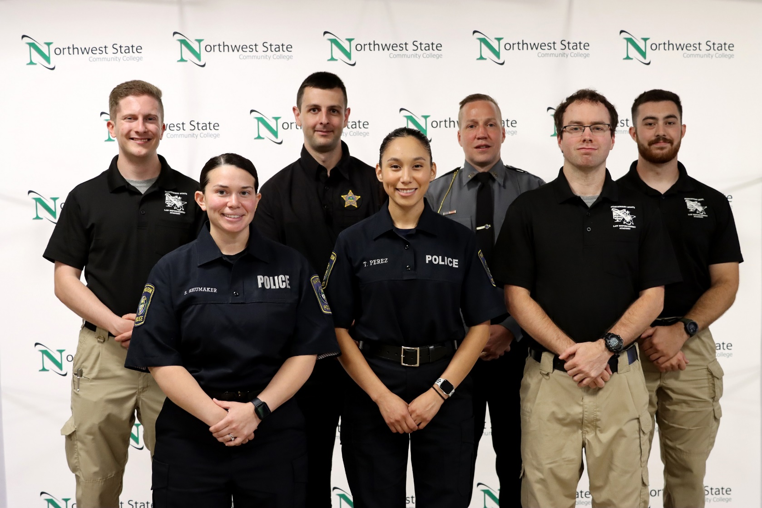

Front Row L to R: Shumaker, Perez, Laver
Back Row L to R: Rufenacht, Vicic, Young, Jackson

