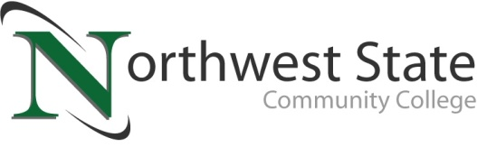

DATE: June 1, 2023
CONTACT: Jim Bellamy 419.267.1267 jbellamy@NorthwestState.edu

Program offerings for your
NORTHWEST STATE Van Wert campus Announced

VAN WERT, Ohio – Northwest State Community College is thrilled to announce the beginning program offerings for Your Van Wert Campus. In total, Northwest State Van Wert is planning to offer more than a dozen onsite programs with more potentially coming.
The program decision process began in September of 2022 with community and school system listening sessions, then continued with an online community survey through the end of the year. The following programs are slated to be offered for all student groups, including traditional college students, students looking for transfer credit, workforce development, and even college credit plus.

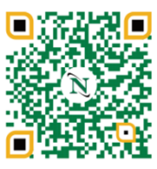
- 2-year Associate degrees
  - Accounting
  - Banking & Finance
  - Business Management
  - Entrepreneurship
  - Marketing
  - Computer Programming
  - Cyber Security Network Administration
  - Electrical Engineering
  - Industrial Technologies

- Short-term certificates
  - Accounting Assistant
  - Entrepreneurship
  - Marketing
  - Computer Technician
  - Cyber Security
  - Industrial Electrical
  - Medical Coding and Billing (online only)

While the Van Wert Campus at 520 E. Sycamore Street is slated to open in Fall of 2024, please remember NSCC is continuing to offer onsite courses in Van Wert at the hospital and its full suite of online program offerings via the main campus. The next round of classes will begin on August 23, 2023. The full course offering schedule for Fall semester can be found by visiting https://northweststate.edu/vanwert. Contact us today to see how Northwest State Van Wert can help put you on that desired career path with our tremendous scholarship and grant opportunities!

Program questions can be directed to Dr. Jon Tomlinson by emailing jtomlinson@northweststate.edu, or visiting our storefront at 122 N. Washington Street. If you have Admissions questions, please email Mandie Heil at aheil@northweststate.edu.

###

Northwest State Community College is an accredited two-year, state-assisted institution of higher education that has served northwest Ohio since 1969. Northwest State is committed to providing a quality, affordable education with personal attention and small class sizes. The College offers associate degrees with numerous transfer options, short-term certificate programs, and workforce training programs designed to meet the needs of local businesses and industries. For more information, visit NorthwestState.edu or call 419.267.5511.

