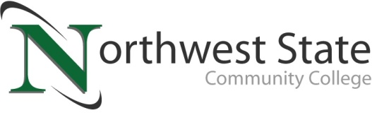

DATE: April 3, 2023
CONTACT: Jim Bellamy 419.267.1267 jbellamy@NorthwestState.edu

NORTHWEST STATE COMMUNITY COLLEGE CENTER FOR LIFELONG LEARNING
TO PRESENT PROGRAM ON NATUROPATHY

Archbold, Ohio – The Center for Lifelong Learning is pleased to welcome Ann Wade Scott, Board Certified Doctor of Naturopathy and Mindy Wade Gendron, Board Certified Traditional Naturopath from Manna Plus on Friday, April 21, 2023 from 9:00 AM until noon to speak about naturopathy and its origins and benefits in Room C200 at the Archbold campus. Ann is a Board Certified Doctor of Naturopathy by the American Naturopathic Medical Association and Mindy is a Board Certified Traditional Naturopath by the American Naturopathic Medical Association.

Adults 50 and over are invited to attend the special program, presented by the NSCC Center for Lifelong Learning (CFLL) at the Archbold Campus on Friday, April 21 in room C200. A continental breakfast and lunch will be served for this presentation. The cost to attend is $14.00.

TO SAVE YOUR SPOT, AND FOR MORE INFORMATION…
Reservations are now being accepted for this special CFLL program, by calling Deb Wikstrom at 419.944.6195, or by email at dwikstrom@NorthwestState.edu. For more information on the CFLL, and other upcoming programs, please visit NorthwestState.edu/lifelong-learning.

###

Northwest State Community College is an accredited two-year, state-assisted institution of higher education that has served northwest Ohio since 1969. Northwest State is committed to providing a quality, affordable education with personal attention and small class sizes. The College offers associate degrees with numerous transfer options, short-term certificate programs, and workforce training programs designed to meet the needs of local businesses and industries. For more information, visit NorthwestState.edu or call 419.267.5511.

