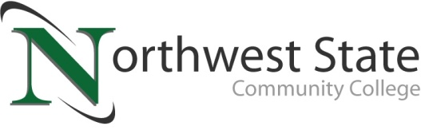

DATE: January 18, 2024
CONTACT: Jim Bellamy 419.267.1267 jbellamy@NorthwestState.edu

NORTHWEST STATE SEEKS 2024 DISTINGUISHED ALUMNI NOMINATIONS

Archbold, Ohio – Northwest State Community College is accepting nominations for the 2024 Distinguished Alumni Award. This award is the most notable recognition presented by the NSCC Alumni Association. Developed in 1998, the Distinguished Alumni Award honors alumni who have achieved recognized prominence in their careers and made significant contributions to their communities and the lives of others.

“Northwest State has more than 12,000 alumni, and eighty-six percent continue to live and work in our six-county service area.” said Robbin Wilcox, Executive Director of Development and the NSCC Foundation. “These graduates are making a positive impact throughout northwest Ohio, and we want to hear those stories.”

To be eligible, at least three years must have elapsed since the nominee graduated from NSCC with an associate degree. All who are nominated will receive a letter announcing their nomination and a form requesting additional information. After all documentation has been received, the NSCC Alumni Association will form a committee that will select the winners for 2024.

“The Distinguished Alumni Award goes beyond recognizing the accomplishments of NSCC alumni. These award winners demonstrate, to both current and potential students, what can be achieved through education and hard work.” said Wilcox.

Nomination forms are available online at NorthwestState.edu/distinguished-alumni-award. To submit a nomination, contact Robbin Wilcox at 419.267.1460 or rwilcox@NorthwestState.edu. Nominations are due by February 29.

###

Northwest State Community College is an accredited two-year, state-assisted institution of higher education that has served northwest Ohio since 1969. Northwest State is committed to providing a quality, affordable education with personal attention and small class sizes. The College offers associate degrees with numerous transfer options, short-term certificate programs, and workforce training programs designed to meet the needs of local businesses and industries. For more information, visit NorthwestState.edu or call 419.267.5511.

