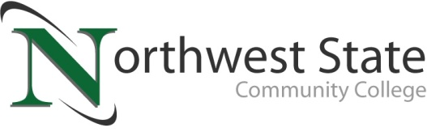

DATE: January 18, 2023
CONTACT: Jim Bellamy 419.267.1267 jbellamy@NorthwestState.edu

NSCC LAUNCHES “BE BOLD” ADULT EDUCATION PATHWAYS

Archbold, Ohio – Northwest State Community College is now enrolling for its first “Be BOLD” cohort starting this fall, which is an adult (25+) learner program that includes hybrid courses (combining online and in-person) with evening options in an accelerated format. Business-related courses will be among the first ones available; namely Business Management, Marketing, Logistics & Supply Chain Management, and Banking & Finance.

Be “BOLD”
The “Be BOLD” pathway at NSCC will lead to a degree or certificate in the above-mentioned programs in the business division. “BOLD” is an acronym for the following:
Balance: Courses will be held at the same time each week in a hybrid format to ensure learners can achieve a work-life-school balance.
Opportunity: NSCC provides the opportunity to build relationships with potential employers, peers and instructors while in the cohort.
Learn: Courses are tailored to provide consistent and meaningful content in an 8-week format.
Degree: Programs are designed to earn a certificate or degree with an exact time layout at NSCC.

Adult learners interested in the “Be BOLD” cohort will also receive assistance with paying for college, free and personal tutoring services, support groups on campus, and resume building.

QUOTABLE
Kristen Davis, NSCC Adult Studies Coordinator, noted that "Northwest State has put a priority on flexible, convenient, and cost-effective education for adults in the surrounding areas. I'm really excited to watch this program take off, so our community members can continue their day-to-day lives while attending school."

Adult learners who have questions about the “Be BOLD” pathway at Northwest State are encouraged to visit NorthwestState.edu/adult-learning online, or contact Adult Studies Coordinator, Kristen Davis, at 419.267.1436 or kdavis@NorthwestState.edu.

###

Northwest State Community College is an accredited two-year, state-assisted institution of higher education that has served northwest Ohio since 1969. Northwest State is committed to providing a quality, affordable education with personal attention and small class sizes. The College offers associate degrees with numerous transfer options, short-term certificate programs, and workforce training programs designed to meet the needs of local businesses and industries. For more information, visit NorthwestState.edu or call 419.267.5511.

