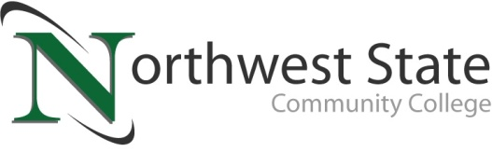

Date: January 12, 2023
Contact: Jim Bellamy, 419.267.1267, jbellamy@NorthwestState.edu

NORTHWEST STATE ANNOUNCES FALL 2022 DEAN’S LIST

ARCHBOLD, OHIO – Northwest State Community College has announced its fall 2022 semester Dean’s List. To be eligible, students must have taken at least 12 credit hours as a full-time student, or 6-11.99 as a part-time student, and have averaged above a 3.5 GPA on a 4.0 scale.

###
Northwest State Community College is an accredited two-year, state-assisted institution of higher education that has served northwest Ohio since 1969. Northwest State is committed to providing a quality, affordable education with personal attention and small class sizes. The College offers associate degrees with numerous transfer options, short-term certificate programs, and workforce training programs designed to meet the needs of local businesses and industries. For more information, visit NorthwestState.edu or call 419.267.5511.

NOTE: The complete list is attached to the email as an .xlsx (Excel) file, sorted by city of residence and then last name. There is a column with an asterisk that denotes 4.0 GPA for the semester.

