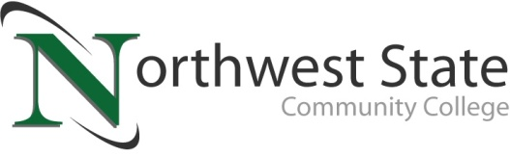

Date: April 30, 2021
Contact: Jim Bellamy | 419.267.1267 | jbellamy@northweststate.edu

northwest state hosts smash invitational tournament

Archbold, Ohio – On April 23rd, Northwest State Community College hosted the first Northwest State Smash Invitational Tournament. Competitors from around the region met in the college atrium to battle each other in Nintendo's Smash Bros. Ultimate.

Over twenty competitors battled for over four hours until NSCC Visual Communication Graphic Design student, Michael Montgomery, came out on top. Participants included students from Patrick Henry High School, Defiance High School, Hilltop West Unity High School, and Bryan High School.

"eSports had a great start in Northwest Ohio but, like other things, COVID made us press the pause button," said Michael Vanderpool, eSports coach and faculty at Northwest State Community College. "Some of the competitive play got regulated to solely online. It was awesome for us to be able to host a live tournament here to end the semester and give these players a chance to compete."

The action was streamed live on Twitch with NSCC students Ethan Eberly, Spencer Barhite, and Hunter Bour providing commentary.

"We couldn't have done it without the help of Northwest State's IT department," continued Vanderpool. "John Shrader and Nick Keller were instrumental in helping to make sure that it went off without a hitch."

To see a replay of the tournament, visit: https://www.twitch.tv/videos/998318900

For more information about esports at NSCC, please contact Michael Vanderpool, mvanderpool@northweststate.edu.

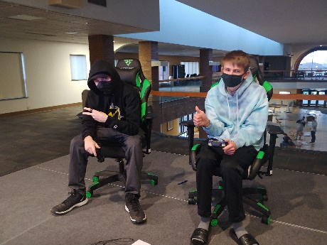
Figure 1: Michael Mongtomery of Deshler (left) wins the NSCC Smash Invitational Tournament. Joshua Bolman of Defiance (right) came in second.

###
Northwest State Community College is an accredited two-year, state-assisted institution of higher education that has served northwest Ohio since 1969. Northwest State is committed to providing a quality, affordable education with personal attention and small class sizes. The College offers associate degrees with numerous transfer options, short-term certificate programs, and workforce training programs designed to meet the needs of local businesses and industries. For more information, visit NorthwestState.edu or call 419.267.5511.

