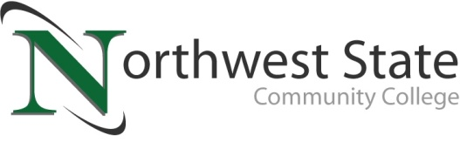

Date: April 28, 2021
Contact: Jim Bellamy | 419.267.1267 | jbellamy@northweststate.edu

PARTNERSHIP PRODUCES SUCCESS IN PAULDING COUNTY
THROUGH NORTHWEST STATE COMMUNITY COLLEGE

Archbold, Ohio – Communication, collaboration, and partnerships are all sometimes a difficult ask. The ultimate goal of all three is to produce action that leads to meeting a goal or need. At Paulding High School, the goal was met as five students completed the Northwest State Community College welding course. The offering, consisting of two college level welding courses, came to fruition alongside the OhioMeansJobs-Defiance and Paulding Counties Office, the Paulding County Economic Development Office, Paulding High School, and Northwest State Community College.

Communication was the driving force behind this offering, as local employers expressed a need for skilled entry level welders. This need, communicated through the Paulding County Economic Development Office, was then brought to the attention of both the local schools and OhioMeansJobs Office. Tim Copsey, Director of the Paulding County Economic Development Office, elaborated on the course. “The collaboration in this inaugural class was a perfect example of how constant communication can benefit us all. A recent survey by your PCED office indicated a need for welding employees amongst the county employers. Sharing that feedback with NSCC, they were able to identify an available classroom and FFA teacher in Mrs. Staci Miller at PEVS. OhioMeansJobs came to the table and assisted with career coaching and funding for this opportunity. It’s a huge collaboration win for Paulding County and goes to show what can happen when we communicate ideas. Kudos to these students for staying engaged and following through to completion.”

Without the availability of a facility and instructor, this program would not have gotten off the ground, but Paulding High School stepped in and filled the gap. Chris Etzler, Principal of Paulding High School, was very accommodating and grateful to see this program start. “This class did exactly what it was intended to do, allow some of our students to learn the foundations of a skill that they can use to be successful after high school. It also gave them an opportunity to meet and network with business owners in our area, who know that these students have skills they can use in the future. I feel like this is opening the door for more trade related courses like this to be offered to our students. I want to thank Northwest State Community College, OhioMeansJobs, and our Economic Development Office for all of their hard work to make this possible for our students.”

Staci Miller, FFA Teacher at the high school, utilized NSCC’s curriculum to instruct the five students. She also played a role in communicating with a local employer about the program. “It was great to be able to teach the students different welding techniques and skills to help them prepare for the workforce and obtain their career goals.” Employer engagement throughout the course was key, and one of those that came to the table was J&J Ag Equipment. Jarrod Mosier, Owner of J&J Ag Equipment, visited the students to see them in action, provide pointers on their technique, and to talk about career opportunities. Jarrod sees this offering as a great asset to the community. “The leadership of the program and the quality of the NSCC welding program is a great benefit to any employer looking for skilled welders in Paulding County.”

OhioMeansJobs-Defiance and Paulding Counties Office continues to play a key role with meeting the workforce needs of the local community. The office not only assists individuals, but aids companies that are looking to upskill their local workforce. Tiffany Dargenson, Workforce Administrator for OhioMeansJobs-Defiance and Paulding Counties, is very satisfied with the outcome of the program. “This welding program is just another example of our office’s ability to assist and meet the local workforce needs. Listening to our local employers and delivering to them skilled labor is always a priority for our office. I’d like to thank Emilie Heersche, our Paulding County Career Coach, for her great effort with the five students.”

Northwest State Community College continues to be at the front of the line with workforce training in Northwest Ohio. Vice President of Workforce Development, Jim Drewes, knows the importance of helping youth develop the skills needed to achieve success. “The Paulding High School class was a great win for the community as a whole, but especially the five young men that completed the offering. The relevant skills gained from this course will help bolster the students’ resumes and help them find employment with local companies. This program saw curriculum from NSCC be used by Paulding High
School, while OhioMeansJobs and Economic Development provided funding, career coaching, and employer outreach. This was the definition of community support.”

Recently these same noted entities, the Superintendents of Western Buckeye ESC and all three county schools met with representatives of ten of Paulding County’s larger employers. This Paulding County Business Advisory Council meeting was held at the Paulding Exempted Village School. All in attendance believe this class and collaboration was a success. Discussion will continue in regard to how future classes like this, and others, can take place in Paulding County.

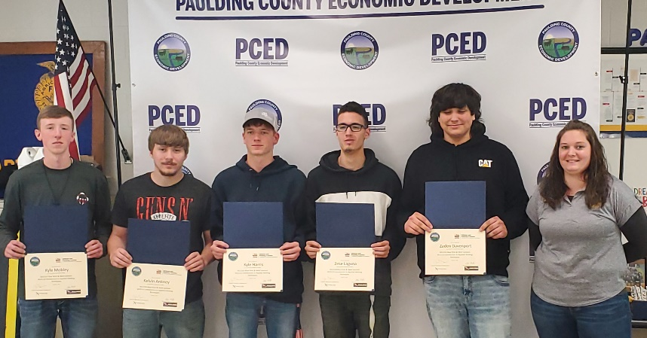
Figure 1: Five Paulding High School students recently completed a college-level welding program provided by Northwest State Community College. Pictured L to R: Kyle Mobley, Kelvin Ankney, Kyle Harris, Ezekiel Laguna, and Zaden Davenport. Staci Miller (FFA Instructor at Paulding HS) is also pictured far right.

###
Northwest State Community College is an accredited two-year, state-assisted institution of higher education that has served northwest Ohio since 1969. Northwest State is committed to providing a quality, affordable education with personal attention and small class sizes. The College offers associate degrees with numerous transfer options, short-term certificate programs, and workforce training programs designed to meet the needs of local businesses and industries. For more information, visit NorthwestState.edu or call 419.267.5511.

