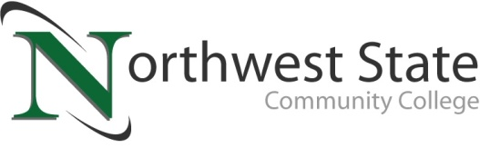

Date: May 6, 2021
Contact: Jim Bellamy | 419.267.1267 | jbellamy@northweststate.edu

NORTHWEST STATE ANNOUNCES
2021 DISTINGUISHED ALUMNI AWARD RECIPIENTS

Archbold, Ohio – Four individuals have been selected to receive the Northwest State Community College Distinguished Alumni Award for 2020-2021. Those individuals will be officially recognized during a special luncheon ceremony prior to Spring Commencement on Saturday, May 15, 2021 at the Archbold Campus. Plaques with their likeness will also be added to the prestigious Alumni wall of award recipients, located outside the Voinovich Auditorium in the College’s E wing. The College will be celebrating both 2020 and 2021 award winners in this celebration, due to COVID forcing last year’s Commencement ceremonies to be held virtually.

“The Distinguished Alumni Award recognizes excellence beyond Northwest State – education, professional achievement, service to the community and more,” said Robbin Wilcox, NSCC Executive Director of Development and the NSCC Foundation. “We are proud to recognize these four graduates with this prestigious award, and we congratulate them for their achievements, and for being tremendous representatives of Northwest State Community College,” Wilcox continued.

ABOUT THE RECIPIENTS
Ruth Kauffman of Archbold is a 2002 graduate of Northwest State, with an Associate of Applied Accounting, Finance & Management degree. Kauffman also attained her Bachelor’s and Master’s degrees from Franklin University in Columbus. Kauffman is the Vice President, Agri Finance Credit Specialist for Farmers & Merchants State Bank in Archbold, having worked with the bank for nearly 20 years.
Terika Elston of Montpelier is a 2001 graduate of the Registered Nursing (RN) program at Northwest State. Panning also attained her Bachelor’s from Bowling Green State University, and her Master’s from Chamberlain College. Elston is the Nursing Manager for In-Patient Rehab for ProMedica in Sylvania, having worked in healthcare for the past 19-plus years.
Dr. Heidi DeSota of Defiance is a 1998 graduate of the Registered Nursing (RN) program at Northwest State. DeSota earned her Bachelor’s from Defiance College, her Master’s from the University of Toledo and her Doctorate from Indiana Wesleyan University. DeSota is the Director of Nursing at Defiance College, and is also an instructor at both Northwest State and The University of Toledo.
Dr. Tiffany Johnston of Fayette is a 2005 graduate of the Registered Nursing (RN) program at Northwest State. Johnston earned her Bachelor’s and Master’s from the University of Phoenix, and her Doctorate from Mount St. Joseph University in Cincinnati. Johnston is the Lead Nursing Director at ProMedica Flower Hospital with 15 years of service within the ProMedica Health System.

ABOUT THE DISTINGUISHED ALUMNI AWARD
The Distinguished Alumni Award represents the most prestigious award presented by the Alumni Association of Northwest State. This award was established in 1998 to honor graduates of Northwest State Community College who have achieved recognized prominence in their chosen career and have made significant contributions to their profession, community and the lives of others. Recipients of the Distinguished Alumni Award represent the ideal of a committed, industrious, and caring individual to whom Northwest State Community College may look as an example. Additional information on the NSCC Distinguished Alumni Award, including a list of previous recipients, is available online at NorthwestState.edu/distinguished-alumni-award.

###
Northwest State Community College is an accredited two-year, state-assisted institution of higher education that has served northwest Ohio since 1969. Northwest State is committed to providing a quality, affordable education with personal attention and small class sizes. The College offers associate degrees with numerous transfer options, short-term certificate programs, and workforce training programs designed to meet the needs of local businesses and industries. For more information, visit NorthwestState.edu or call 419.267.5511.

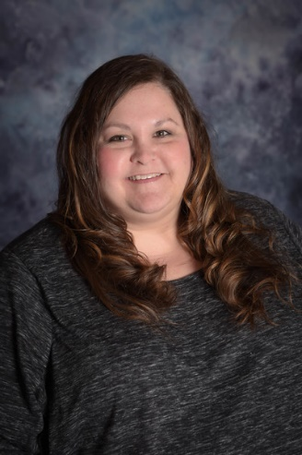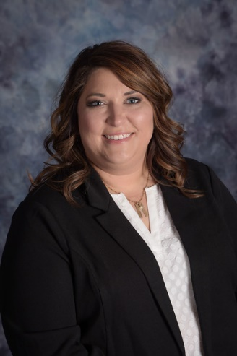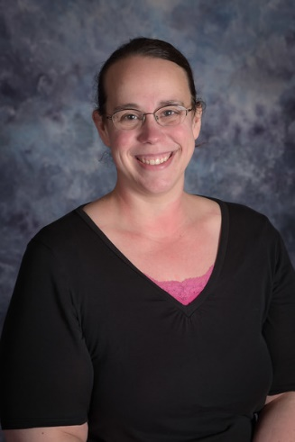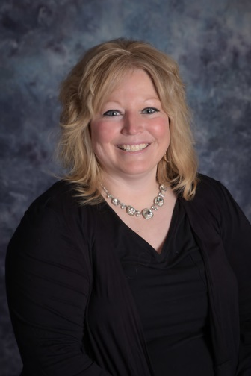

From L to R: Heidi DeSota, Tiffany Johnston, Ruth Kauffman, Terika Elston

