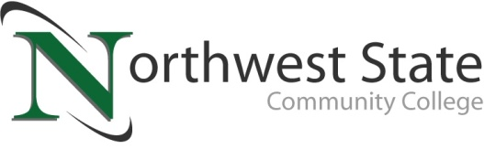

DATE: December 6, 2022
CONTACT: Jim Bellamy 419.267.1267 jbellamy@NorthwestState.edu

NORTHWEST STATE TO HOST GAME CON ’23,
A GAMING AND POP CULTURE CONVENTION

Archbold, Ohio – Northwest State Community College will be the site of Game Con ’23, “the premier pop culture convention held by NSCC Thunder (the College’s official eSports team) and Northwest State Community College,” on Saturday, January 7 from 9:00 a.m. to 3:30 p.m. The event is free to attend, and all ages are welcome. Select tournaments may have entry fees, as outlined below.

Game Con ’23 will include a Super Smash Bros. Ultimate tournament with a prize pool over $300 (a $5 entry fee is required to participate in the Smash tournament.) A 16-team Rocket League doubles tournament with a $250 prize pool, and a Cosplay Contest with a $250 prize pool will also be part of the event.

PLENTY OF ACTIVITIES AVAILABLE…
Some of the non-tournament activities that day are scheduled to include:
- Artist Alley, Vendors and Authors
- Costume and Cosplay meetups & photo activities
- Open console play with Nintendo Switch, Oculus Rift, PlayStation 4, as well as retro consoles
- Door prizes, Lego build station and much more!

THANKS TO THE EVENT SPONSORS…
Event sponsors currently include Worthington Industries, Sauder Manufacturing, Bryan GameStop, and N.W.O. Gamers.

ADDITIONAL INFORMATION…
Additional information, including registration link, entry fees (where applicable), etc., is always available at https://www.eventbrite.com/e/game-con-23-tickets-446155873227?aff=Flyer. Follow NSCC Thunder on social media at Instagram.com/nscc.thunder.
###

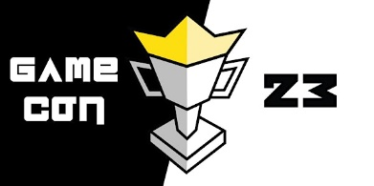
Northwest State Community College is an accredited two-year, state-assisted institution of higher education that has served northwest Ohio since 1969. Northwest State is committed to providing a quality, affordable education with personal attention and small class sizes. The College offers associate degrees with numerous transfer options, short-term certificate programs, and workforce training programs designed to meet the needs of local businesses and industries. For more information, visit NorthwestState.edu or call 419.267.5511.

