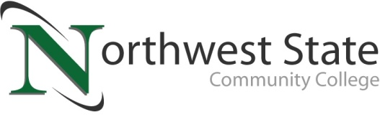

DATE: November 14, 2023
CONTACT: Jim Bellamy 419.267.1267 jbellamy@NorthwestState.edu

NSCC RECEIVES $891,999 “CHOOSE OHIO FIRST” GRANT

Archbold, Ohio – Northwest State Community College received a “Choose Ohio First” grant in the amount of $891,999.96 for fiscal year 2024, from the State of Ohio and the Ohio Department of Higher Education (ODHE). The award letter, dated November 7, 2023, noted that the State has committed more than $200 million over the past five years to STEM and STEM Education scholarships.

“FIRST TIME FOR ALLIED HEALTH AND NURSING”
The uniqueness of this Choose Ohio First grant is that it provides funding for the first time for Allied Health and Nursing scholarships at NSCC. Eligible healthcare programs offered at NSCC for this grant include: Registered Nursing, Practical Nursing, Medical Assisting, and Phlebotomy. Additional information on NSCC degree, certificate and transfer options are always available online at NorthwestState.edu.

QUOTABLES
"The strength of Ohio's economy depends on having a skilled workforce in the STEM fields," said Chancellor Randy Gardner. "Northwest State Community College has done a great job of preparing its STEM scholars, and I am pleased to have Northwest State Community College among the latest Choose Ohio First awardees."

Dr. Todd Hernandez, NSCC President, added “We are grateful to Chancellor Gardner, the ODHE and the State of Ohio for this Choose Ohio First grant award. NSCC offers great healthcare degree and certificate programs that directly lead to career opportunities with local healthcare facilities, providing family-sustaining wages. Access to education, training, and services is essential to our mission and our new Strategic Plan.”

###

Northwest State Community College is an accredited two-year, state-assisted institution of higher education that has served northwest Ohio since 1969. Northwest State is committed to providing a quality, affordable education with personal attention and small class sizes. The College offers associate degrees with numerous transfer options, short-term certificate programs, and workforce training programs designed to meet the needs of local businesses and industries. For more information, visit NorthwestState.edu or call 419.267.5511.

