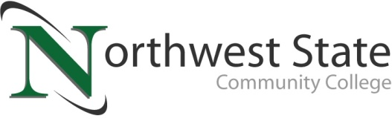

DATE: October 30, 2023
CONTACT: Jim Bellamy 419.267.1267 jbellamy@NorthwestState.edu

NORTHWEST STATE COMMUNITY COLLEGE FOUNDATION
PRESENTS $952,300 CHECK TO BOARD OF TRUSTEES

Archbold, Ohio – The Northwest State Community College Board of Trustees met in regular session on Friday, October 27th at the Archbold campus. After roll call, Robbin Wilcox, NSCC Executive Director for Development & NSCC Foundation and Foundation Board Chair Peter Beck presented the Board with a check in the amount of $952,300. The money is designated for student scholarships, equipment, outreach programs and student support efforts.

NEARLY $8 MILLION HAS BEEN PROVIDED…
Nearly $8 million has been provided through the generosity of businesses and individuals who have supported the Foundation over the past ten years. Peter Beck, NSCC Foundation Board Chair, applauded the generosity of individuals and businesses who have donated to the NSCC Foundation, for helping make this presentation possible. Beck also gave kudos to Robbin Wilcox for her tireless work in raising funds and awareness to help aid student success.

EMERITUS STATUS BESTOWED ON TWO
One of the final items on the agenda was the approval of Emeritus status for Marsha Buehrer and Dr. Robert Hall, who each proudly dedicated their time and talents to Northwest State for many years. Buehrer worked in a variety of administrative roles at the College, while Hall represented Henry County on the Board of Trustees. Both will be officially recognized during a special dinner ceremony on Monday, December 18 just prior to the College’s Fall Commencement.

In other Board action:
- Approved the promotion of Krista Maassel to Customer Service Specialist, Felicia Skeens to Success Center Coordinator, Audrey Lehman to Grants Compliance Officer, Thomas Plummer to Manufacturing Training Manager, Melissa Durham to Associate Director-Financial Aid, Jessica Thome to Counselor-Financial Aid, and Shantelle Cline to Lieutenant of Campus Police.
- Approved the employment of Scott Campbell (Chief of Police), Franklin Roberts (Dean of STEM & Industrial Technologies), Riley Dietrich (Administrative Assistant-Advising & Learning Center), Kassie Kelly (Administrative Assistant-IBEW Apprenticeships & Apollo), and Sandra Manon (Executive Administrative Assistant-Vice President for Academics).
- Approved a gift in the amount of $1,000 to the STEM & Industrial Technologies division.
- Approved amended Fees Policy, mirroring House Bill 33.
- Approved amended Student Code of Conduct Policy, also reflective of House Bill 33.
- Approved moving the February 2024 Board meeting from February 23, 2024 to February 16, 2024 due to scheduling conflict.
- Approved miscellaneous employment contracts, two retirements and three resignations.

###

Northwest State Community College is an accredited two-year, state-assisted institution of higher education that has served northwest Ohio since 1969. Northwest State is committed to providing a quality, affordable education with personal attention and small class sizes. The College offers associate degrees with numerous transfer options, short-term certificate programs, and workforce training programs designed to meet the needs of local businesses and industries. For more information, visit NorthwestState.edu or call 419.267.5511.

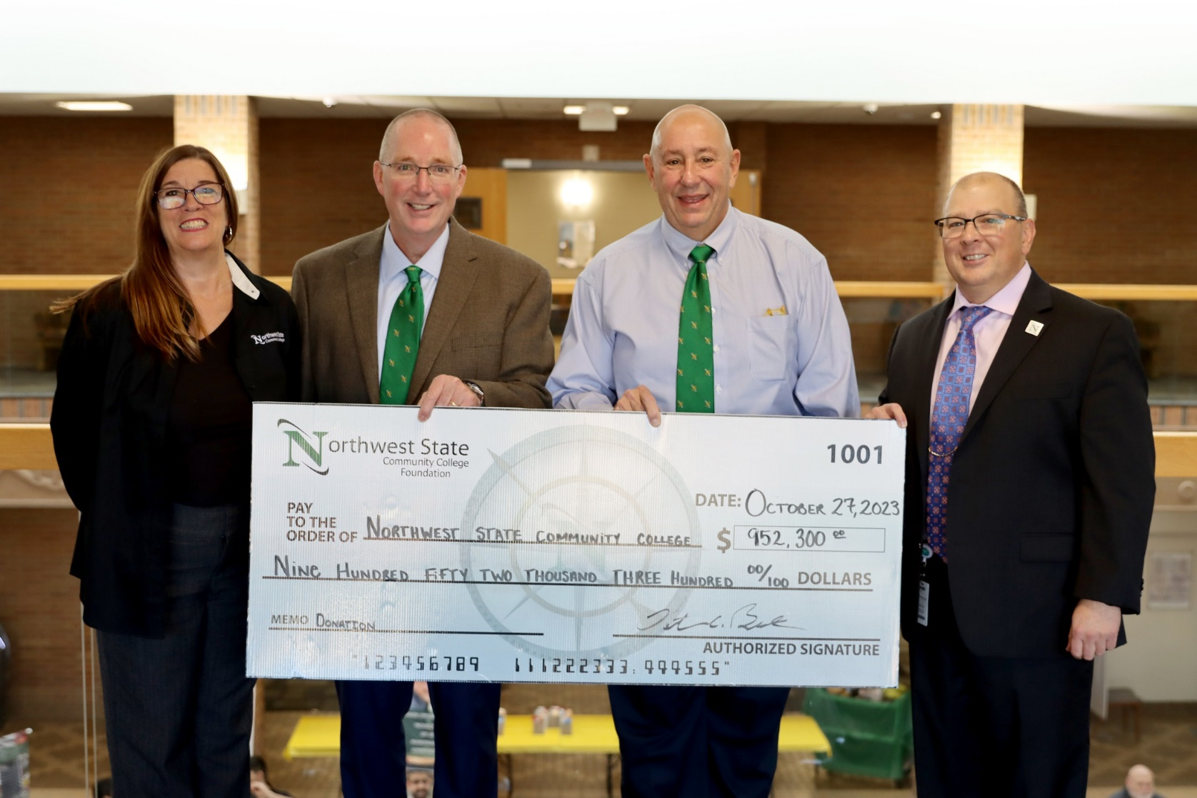

CAPTION: The NSCC Foundation presented a check to the NSCC Board of Trustees for $952,300 at the October 27, 2023 meeting. Pictured L to R: Robbin Wilcox (NSCC Executive Director of Development and Foundation), Scott Mull (Chair, NSCC Board of Trustees), Peter Beck (Chair, NSCC Foundation Board), and Dr. Todd Hernandez (NSCC President)

