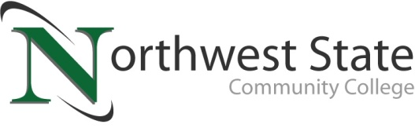

DATE: March 23, 2023
CONTACT: Jim Bellamy 419.267.1267 jbellamy@NorthwestState.edu

Why Not Take College Courses IN VAN WERT NOW?

VAN WERT, Ohio –

Is your dream to be a college graduate, but never took that first step?
Do you have past college credit but never completed your degree?
Are you ready for that next promotion at work?
Has it always been inconvenient, too costly, or too much travel to get that certification?
Are you a high school student who wants a head start on your college education at no cost, savings thousands of dollars?

If you answered Yes to any of these questions, PLEASE read on.

Your Van Wert Campus of Northwest State Community College is excited to announce the opening of registration for our Summer and Fall 2023 classes. We have partnered with Van Wert Health to house classes in the hospital’s conference rooms while our Sycamore Street location undergoes renovation. Classes are scheduled to be held in an 8-week hybrid format (1.5 hours of face-to-face lecture with online assignments) on weeknights and Saturday mornings.

Our onsite class offerings allow you to enter several Northwest State career pathways – Business, Computer Systems, Industrial Tech, and Bachelor’s Bound (i.e. those looking to ultimately transfer to a 4-year university). Classes are available for all student groups, including traditional aged college students, non-traditional/part-time students, students looking to take summer classes and transfer credit back to their home university, workforce development and upskilling, and college credit plus/dual enrollment.

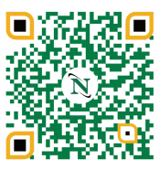
Choose convenience and cost savings! To begin your future educational career or gather more information, please visit the Van Wert Campus website at https://northweststate.edu/vanwert. On our Van Wert Campus website, you have access to review all our Academic Divisions, ask any Admissions questions, review Financial Aid and scholarship information, and apply to begin your future at Northwest State Community College. This QR code will take you right there!

You may contact the Dean, Dr. Jon Tomlinson, directly by emailing jtomlinson@northweststate.edu, or visiting our storefront at 122 N. Washington Street. Specific questions about enrolling can be directed to Mandie Heil (aheil@northweststate.edu). We look forward to serving YOU!

###

Northwest State Community College is an accredited two-year, state-assisted institution of higher education that has served northwest Ohio since 1969. Northwest State is committed to providing a quality, affordable education with personal attention and small class sizes. The College offers associate degrees with numerous transfer options, short-term certificate programs, and workforce training programs designed to meet the needs of local businesses and industries. For more information, visit NorthwestState.edu or call 419.267.5511.

