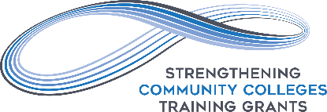
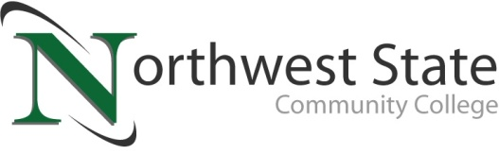

DATE: January 31, 2023
CONTACT: Jim Bellamy 419.267.1267 jbellamy@NorthwestState.edu

NSCC CREATES INNOVATIVE SHORT-TERM CERTIFICATE PROGRAMS WITH
$1.7 MILLION U.S. DEPARTMENT OF LABOR GRANT

Archbold, Ohio – In 2021, The U.S. Department of Labor awarded $40 million through the Strengthening Community College Training Grants program, which helped community colleges meet the labor market demand for a skilled workforce. Northwest State received nearly $1.7 million of that total award, and the College is putting that money to good use with an innovative short-term certificate program in Computer Aided Manufacturing (CAM) or Industrial Automation. NSCC is currently enrolling for spring term classes in these programs, so those interested in participating are encouraged to apply now!

INNOVATIVE PROGRAMMING
The CAM program is a 19 credit hour program, eligible for NIMS and OSHA certifications. The Industrial Automation program is a 20 credit hour program, eligible for FANUC and OSHA certifications. Both courses provide entry every 6 weeks. The programs have 24/7 hybrid and online learning options available, along with flexible lab scheduling (evenings and weekends) providing the flexibility to learn at your own pace – one credit hour at a time. These one credit hour courses are also stackable back into traditional NSCC certificate and/or degree program tracks.

These programs are ideal for individuals who are looking for a path to a new career, or perhaps advancement in their current career path. Financial assistance is available through the school in the form of scholarships, grants and student loans.

QUOTABLES
“The Strengthening Community Colleges Training Grants will play an important role in helping workers to reskill as quickly as possible with industry-recognized credentials and accelerated pathways to degrees,” said Assistant Secretary for Employment and Training John Pallasch. “These grants are among the range of actions the Department is taking to aid American workers and employers as our nation combats the coronavirus pandemic.”

“Our number one reason for doing these flexible programs is so learners can schedule classes around their lives, not life around their classes,” added Dr. Ryan Hamilton, Dean of STEM and Industrial Technologies at Northwest State.

GET STARTED!
The 6B cohort begins on 2/21/23, while the 6C cohort begins 4/4/23. For more information about these programs, visit NorthwestState.edu/scc or contact Dr. Ryan Hamilton at rhamilton@NorthwestState.edu or 419.267.1273.

###

Northwest State Community College is an accredited two-year, state-assisted institution of higher education that has served northwest Ohio since 1969. Northwest State is committed to providing a quality, affordable education with personal attention and small class sizes. The College offers associate degrees with numerous transfer options, short-term certificate programs, and workforce training programs designed to meet the needs of local businesses and industries. For more information, visit NorthwestState.edu or call 419.267.5511.

