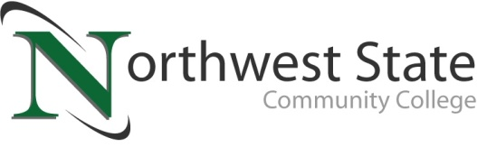

DATE: January 23, 2023
CONTACT: Jim Bellamy 419.267.1267 jbellamy@NorthwestState.edu

vAN wERT cAMPUS OF NORTHWEST STATE COMMUNITY COLLEGE ANNOUNCES mORE SPRING 2023 CLASSES IN VAN WERT

VAN WERT, Ohio – Your Van Wert Campus of Northwest State Community College is excited to announce the release of its 2023 spring 8B semester class schedule. The second half of NSCC’s spring semester schedule will again feature 8-week long courses taught with face-to-face lecture occurring one-night-a-week. The courses will begin on March 20, 2023.

Van Wert Health, located at 1250 S. Washington Street, has graciously agreed to allow Northwest State to house classes in the hospital’s conference rooms while our Sycamore Street location undergoes renovation. Classes are scheduled to be held on Monday, Tuesday, Wednesday, or Thursday evenings, with our student Success Seminar and optional Writing Center assistance taking place on alternating Saturday mornings.

The schedule below will allow students to enter several of Northwest State’s career pathways, including Business, Healthcare, Social Behavioral Sciences, Communications, English, & Humanities, Public Services, Engineering Technology, Industrial Technology, and Math & Natural Sciences. Classes are available for all student groups, including traditional college students, students looking for transfer credit, workforce development, and even college credit plus.

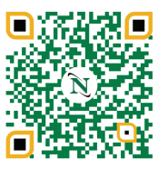
To begin your future educational career or gather more information, please visit the Van Wert Campus website at https://northweststate.edu/vanwert. On our Van Wert Campus website, you have access to review all our Academic Divisions, ask any Admissions questions, review Financial Aid and scholarship information, and apply to begin your future at Northwest State Community College. This QR code will take you right there!

You may contact the Dean, Dr. Jon Tomlinson, directly by emailing jtomlinson@NorthwestState.edu, or visiting our storefront at 122 N. Washington Street. We look forward to serving YOU!

Day | Course Offering
Monday (5:45-8:15pm) | STA120 Introduction to Statistics (3 credits)
Tuesday (5:45-8:15pm) | BUS101 Introduction to Business (3 credits)
Wednesday (5:45-8:15pm) | ENG111 Composition 1 (3 credits)
Thursday (5:45-8:15pm) | IND107 Print Reading & Sketching (2 credits)
Saturday  9:00-10:50am on March 25, April 8, April 22, and May 6  11:00am-12:50pm on March 25, April 8, April 22, and May 6 | GSD100 Success Seminar (1 credit)  Writing Center (optional, 0 credit)

###

Northwest State Community College is an accredited two-year, state-assisted institution of higher education that has served northwest Ohio since 1969. Northwest State is committed to providing a quality, affordable education with personal attention and small class sizes. The College offers associate degrees with numerous transfer options, short-term certificate programs, and workforce training programs designed to meet the needs of local businesses and industries. For more information, visit NorthwestState.edu or call 419.267.5511.

