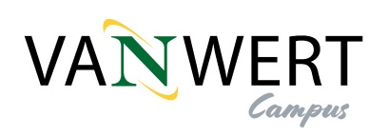
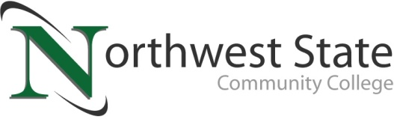

Date: December 5, 2023
Contact: Jim Bellamy | 419.267.1267 | jbellamy@NorthwestState.edu

Indiana Tech and NORTHWEST STATE Community College
ANNOUNCE NEW ARTICULATION AGREEMENTs

Van Wert, Ohio –Northwest State Community College and Indiana Institute of Technology (Indiana Tech) are excited to offer five (5) distinct articulation agreements that will benefit current and future students of both schools. Starting immediately, graduates from Northwest State may transfer up to 66 college credits and be eligible for admission with junior standing to Indiana Tech in Fort Wayne, IN. Articulation agreements such as this help students by simplifying the transfer process from a community college to the 4-year university of their choice, especially when a student’s decision crosses state lines.

Jon Tomlinson, Dean of the Van Wert Campus for Northwest State, noted “All five (5) agreements will assist interested students in completing a Bachelor of Science degree from Indiana Tech. The specific areas include Criminal Justice, Human Services, Data Analytics, Quality Management, and Business Administration”.

Jason Rickenberg, Dean of Business & Public Services for Northwest State, added “This articulation agreement furthers our partnership opportunities with 4-year schools in Indiana. The proximity between Fort Wayne and our new Van Wert campus helps strengthen educational opportunities for all our students, particularly those who live in Paulding and Van Wert counties.”

Indiana Tech’s Vice President for Enrollment Management, Dr. Steve Herendeen, commented, “Accessible and affordable education that prepares students for career success have long been the top priorities for both Indiana Tech and Northwest State. We are excited for this partnership because it will effectively help more students earn associate and bachelor’s degrees that equip them with the knowledge, skills and credentials required in these degree fields. This agreement takes our shared commitment to students to an even higher level – those who earn a degree at Northwest State Community College are guaranteed to have all of their credits transfer to Indiana Tech and easily move towards completion of their bachelor’s degrees.”

“We at Northwest State are continuously working to increase educational access for all our student populations. Agreements such as this allow current and future students the opportunity to take classes locally, and at a much-reduced tuition rate, then seamlessly continue their career path to a 4-year institution,” said Dr. Todd Hernandez, President of Northwest State Community College.

While the Van Wert campus at 520 E. Sycamore St. (former Kennedy Manufacturing building) is slated to open in early 2025, NSCC is continuing to offer on-site courses in Van Wert at OhioHealth Van Wert Hospital and its full suite of online program offerings via the main campus. The full course offering schedule for spring semester (January 2024) can be found by visiting NorthwestState.edu/VanWert. Questions can be directed to Dr. Jon Tomlinson by emailing jtomlinson@northweststate.edu, or visiting NSCC’s storefront location at 122 N. Washington Street.

About Indiana Tech
Established in 1930 in Fort Wayne, Indiana, as an engineering college, today’s Indiana Tech is a comprehensive university that educates students beyond its home base with regional service centers throughout Indiana and Kentucky, as well as online programs that serve students worldwide. This private, not-for-profit university specializes in career-oriented certificate and degree programs in business, engineering, computer science, criminal justice, cybersecurity, health care administration, information technology, and many others. We prepare students for active participation, career advancement, and leadership in the global 21st century society, and motivate them toward lives of significance and worth.

About Northwest State Community College
Northwest State Community College is an accredited two-year, state-assisted institution of higher education that has served northwest Ohio since 1969. Northwest State is committed to providing a quality, affordable education with personal attention and small class sizes. The College offers associate degrees with numerous transfer options, short-term certificate programs, and workforce training programs designed to meet the needs of local businesses and industries. For more information, visit NorthwestState.edu or call 419.267.5511.

###

